RAM-IT: ITRO’s ChatBot & Ticketing System Website

Project Documentation Submitted to the Faculty of the

School of Computing and Information Technologies

Asia Pacific College

In Partial Fulfillment of the Requirements for

Systems Analysis and Detailed Design for IT

MSYADD1

By

Aloya, Jayson

Langcauon, John Christopher

Prion, Jan Gabriel

Sajul, Marc Julian

Zamora, Marc

ASIA PACIFIC COLLEGE

Approval Sheet

RAM-IT: ITRO’s ChatBot & Ticketing System Website

Prepared and Submitted by

*Aloya, Jayson*

*Langcauon, John Christopher*

*Prion, Jan Gabriel*

*Sajul, Marc Julian*

*Zamora, Marc*

In Partial Fulfillment of the Requirements for the Degree of

Bachelor of Science in Information Technology

Examined and Recommended for Acceptance and Approval for

Research/Capstone Presentation

___________________________

Ms. Jo Anne M. de la Cuesta, Adviser

Panelists

___________________________

Doc. Manuel L. Calimlim, Jr., Panel Member

|  |  |
| --- | --- |
| ___________________________ | ___________________________ |
| Ms. Roselle Wednesday L. Gardon, Panel Member | Mr. Christopher T. Carpio, Panel Member |

Acceptance and Approved in Partial Fulfillment of the Requirements for the Degree of

Bachelor of Science in Information Technology

___________________________

Rhea-Luz R. Valbuena

Executive Director

School of Computing and Information Technologies

Table of Contents

Executive Summary i

List of Figures ii

List of Tables iii

I. Introduction 1

1.1 Project Context 1

1.2 Statement of the Problem 1

1.3 Objectives 1

1.4 Significance of the Project 2

1.5 Scope and Limitations 2

II. Review of Related Literature / Systems 3

III. Technical Background 4

3.1 Current System 4

3.2 Proposed System 4

IV. Methodology 4

4.1 Requirements Analysis 4

4.1.1 Product Backlog / User Stories 4

4.1.2 Event Tables 4

4.1.3 Use Case Diagrams 4

4.1.4 Use Case Full Description 4

4.2 Gap Analysis 4

4.3 System Analysis and Design 5

4.3.1 Context Diagram 5

4.3.2 Data Flow Diagrams 5

4.3.3 Entity-Relationship Diagrams 5

4.3.4 Activity Diagrams 5

4.3.5 Object Diagrams 5

4.3.6 Class Diagrams 5

4.3.7 Sequence Diagrams 5

4.3.8 Package Diagram 5

4.3.9 Component Diagram 5

4.3.10 Deployment Diagram 5

V. Results and Discussion 6

5.1 Release Plan 6

5.2 Prototype 6

5.3 Use Classes and Characteristics 6

VI. Conclusion 7

References 8

Appendices 9

Appendix A: Project Vision 9

Appendix B: Schedule 10

Appendix C: Product Roadmap 11

Appendix D: Users’ Manual 12

Appendix E: Team Meetings 13

Appendix F: Source Code 14

# Executive Summary

Optimum Five brings to the members of the APC community, RAM-IT a Chatbot and Ticketing System website, where immediate IT-related concerns can be answered by the Chatbot. If the ChatBot’s answer cannot satisfy the inquirer’s concern, the ticketing system will allow members of the APC community to submit a ticket where an ITRO IT Specialist will be the one to answer in the span of 24 hours. This system will not only give members of the APC community assurance on the ITRO answering their concerns, but will also provide ITRO the flexibility on handling different types of concerns coming from the members of the APC Community.

The ITRO has been needing a system where they can provide members of the APC community the support in terms of online inquiries in a time efficient manner. They have also needed a system in which they can delegate, organize, and track these online inquiries, and furthermore into that, as online inquiries can be repetitive at times. The system will enable ITRO to prioritize on inquiries and concerns that need their direct assistance, as the Chatbot will help on answering frequently asked problems by the APC community.

As the team researched for ways to help the ITRO, they have concluded that a respectable number of colleges like Asia Pacific College, use a similar system to a ticketing system that allows their school community and their IT staff to have a more efficient way in handling with inquiries. The team also had researched that ChatBot’s provide a way more interesting and interactive type of experience, and it enables members of the school community to have more immediate answers if the Chatbot is able to answer the prompted inquiry or concern.

The system will have its milestones in the span of the year 2022 till March 2023, and with the team’s assistance and guidance from their project adviser, consultants, and the client, the project will be continuously improved or iterated by the project team.

# List of Figures

Figure 1: Use Case Diagram 18

Figure 2: Context Diagram 34

Figure 3: Data Flow Diagrams (Level 0) 35

Figure 4: Proposed DFD Level 1: Log to Account 36

Figure 5: Proposed DFD Level 1: Submit a Ticket 36

Figure 6: Proposed DFD Level 1: Assign Ticket 37

Figure 7: Proposed DFD Level 1: Rate Service 37

Figure 8: Proposed DFD Level 1: Manage Ticket 38

Figure 9: Proposed DFD Level 1: Produce Monthly Report 38

Figure 10: Proposed DFD Level 2: Input Ticket Details 39

Figure 11: Proposed DFD Level 2: Closed Ticket 39

Figure 12: Proposed DFD Level 2: Filter Closed Ticket List 40

Figure 13: Proposed DFD Level 2: Produce Monthly Report 40

Figure 14: Entity-Relationship Diagram 41

Figure 15: Activity Diagrams (Monthly Report) 41

Figure 16: Activity Diagrams (ChatBot & Ticketing System) Part 1 42

Figure 17: Activity Diagrams (ChatBot & Ticketing System) Part 2 43

Figure 18: Object Diagram 44

Figure 19: Class Diagram 44

Figure 20: Proposed Sequence Diagram 45

Figure 21: Package Diagram 46

Figure 22: Component Diagram 47

Figure 23: Deployment Diagram 48

Figure 24: Machine State Diagram (Chatbot) 49

Figure 25: Machine State Diagram (Ticketing System) 50

Figure 26: Release Plan 52

Figure 27: Log In (Client) 53

Figure 28: Home Part 1 (Client) 53

Figure 29: Home Part 2 (Client) 54

Figure 30: Home Part 3 (Client) 54

Figure 31: Ticket History Part 1 (Client) 55

Figure 32: Ticket History Part 2 (Client) 55

Figure 33: Ticket History Part 3 (Client) 56

Figure 34: Ticket Request Template (Client) 56

Figure 35: Ticket Chatbox Open (Client) 57

Figure 36: Ticket Chatbox Closed (Client) 57

Figure 37: Log In (ITRO) 58

Figure 38: Home (ITRO) 58

Figure 39: Ticket Chatbox (ITRO) 59

Figure 40: Ticket History (ITRO) 59

Figure 41: Ticket Chatbox Closed (ITRO) 60

Figure 42: Login (Student/ITRO/Supervisor) 61

Figure 43: Home Page (Student) 61

Figure 44: Tickets Page (Student) 62

Figure 45: Add Ticket (Student) 62

Figure 46: Profile (Student) 63

Figure 47: Chatbot (Student) 63

Figure 48: Chatbot Interaction (Student) 64

Figure 49: Home Page (Supervisor) 64

Figure 50: Tickets Page (Supervisor) 65

Figure 51: Assign Ticket to an ITRO employee (Supervisor) 65

Figure 52: Profile (Supervisor) 66

Figure 53: Home Page (ITRO) 67

Figure 54: Profile (ITRO) 67

Figure 55: Ticket Page (ITRO) 68

Figure 56: Ticket# details (ITRO) 68

Figure 57: Product Roadmap 75

Figure 58: Source Code Github 76

Figure 59: Minutes of the Meeting - 8/28/22 Sunday 77

Figure 60: Minutes of the Meeting - 8/29/22 Monday 78

Figure 61: Minutes of the Meeting - 8/31/22 Wednesday 79

Figure 62: Minutes of the Meeting - 9/7/22 Wednesday 80

Figure 63: Minutes of the Meeting - 9/15/22 Wednesday 81

Figure 64: Minutes of the Meeting - 9/20/22 Tuesday 82

Figure 65: Minutes of the Meeting - 9/21/22 Thursday 83

Figure 66: Minutes of the Meeting - 9/23/22 Friday 84

Figure 67: Minutes of the Meeting - 9/25/22 Sunday 85

Figure 68: Minutes of the Meeting - 9/27/22 Tuesday 86

Figure 69: Minutes of the Meeting - 9/29/22 Thursday 87

Figure 70: Minutes of the Meeting - 9/30/22 Friday 88

Figure 71: Minutes of the Meeting - 10/1/22 Saturday 89

Figure 72: Minutes of the Meeting - 10/1/22 Saturday 90

Figure 73: Minutes of the Meeting - 10/20/22 Tuesday 91

Figure 74: Minutes of the Meeting - 10/20/22 Thursday 92

Figure 75: Minutes of the Meeting - 11/4-6/22 Friday - Sunday 93

# List of Tables

Table 1: List of Processes 8

Table 2: User Stories with Acceptance Criteria 14

Table 3: Product Backlog 17

Table 4: Event Table 17

Table 5: Use Case Full Description (Log In Account) 19

Table 6: Use Case Full Description (Inquire through ChatBot) 20

Table 7: Use Case Full Description (Submit a Ticket) 21

Table 8: Use Case Full Description (Assign Ticket) 22

Table 9: Use Case Full Description (Generate Reminder Notification) 23

Table 10: Use Case Full Description (Messaging via Ticketing Chat) 24

Table 11: Use Case Full Description (Rate Service) 25

Table 12:Use Case Full Description (Manage Ticket) 26

Table 13:Use Case Full Description (Produce Monthly Report) 27

Table 14: Gap Analysis 33

Table 15: Use Classes and Characteristics 69

Table 16: Roles & Responsibilities 74

# Introduction

## Project Context

Asia Pacific College or APC is a private college that promotes itself to those aspiring to attain world-class education with a strong IT-based foundation. Asia Pacific College is a school that can provide access to IT laboratories, school computers, multimedia studio, computer network, and internet connection. This enhances the quality of education and widens the learning opportunities for the students and other members of the APC academic community. The Office of Information Technology Resource or ITRO is a department in APC that manages all the IT related aspect within the organization. The ITRO provides services that is specialized in assisting and managing the IT systems, devices, infrastructure, and cybersecurity. The ITRO is a customer support department available for all the members of APC community. To inquire assistance APC community members can make an appointment through email in a Microsoft outlook account or personally contacting any available ITRO staff member inside the school premises.

Modern systems and IT solutions have been available for managing customer service request for the past century. Recent trend of organizations using tools such as a ticketing system that helps manage, track, and process customer issues from submission to resolution. Ticketing system allows an office to coordinate a response to increase its service effectiveness and efficiency. This is where the project RAM-IT enters the picture. RAM-IT promises a ticketing system that aims to free up time and resource for the ITRO. The ticketing system will automatically distribute and assign tickets to ITRO. Students can track the progress of their submitted ticket and review the tickets. RAM-IT will also feature an online chat bot that will automate messages to furthermore assist the ticketing system of ITRO. RAM-IT aims to improve the customer service aspect of ITRO.

## Statement of the Problem

APC is in need of a system that enables ITRO to efficiently provide support and information to the APC Community.

1.) ITRO personnel are unable to provide support for online inquiries and concerns in a time efficient manner due to their demanding work load.

2.) ITRO personnel are unable to delegate, organize, & track the progress of online inquiries and concerns.

3.) ITRO personnel are unable to track the priority level of a concern which leads to them answering frequently asked problems one-by-one before answering specific inquiries that requires more attention.

## Objectives

To develop a system that enables ITRO to efficiently provide support and information to the APC Community.

1.) To develop a system that provides online customer support at any time of the day

2.) To develop a system that centralizes online inquiries and concerns in one singular place for easy delegation, organizing, and tracking of progress.

3.) To develop a system that answers frequently asked problems in place of ITRO which enables ITRO to focus on inquiries or concerns that is much more necessary for an ITRO Personnel to answer. To provide the ability for an ITRO Personnel to be able to view the priority level of the inquiry or concern, so they can tackle inquiries based on the level of priority.

## Significance of the Project

1. ITRO – will benefit from the ticketing system because it can save time, and resources when processing multiple customer support inquiries.

2. APC Community

2.a. APC Students – will benefit from the project because it will help the ITRO handle the fluctuation of inquiry, most the time during the first few weeks of a school term.

2.b. APC Instructor/Teachers – will benefit from the project because new and part time instructors tend to ask more questions. Teachers will have the ability to send inquiries.

2.c. APC School & Offices – will benefit from the project because it gives departments the ability to send a detailed inquiry that is needed in school for management and operations.

## Scope and Limitations

1. The project only is available for those with the apc.edu.ph account.

2. The proponents will cover the development of the website, to able the ITRO to use the website.

2.A. The proponents will be handling the production and development of the website

2.B. The ITRO will provide the responses, while the proponents update the system using the ITRO’s responses

3. The project is for the ITRO in APC.

# Review of Related Literature / Systems

***1. Helpdesk***

Information technology (IT) is the use of computers and other telecommunications systems for data archiving, retrieval, transmission, and modification. It is made up of the hardware and software that perform the duties that are expected of them. There is no such thing as a perfect machine, thus it is understood that IT help keeps the system healthy and the technology up to date. This is how technology problems are helped by IT support. [1] Enabling hassle-free access to a service, a mobile ticketing system in any given service ensures the satisfaction of a client. [2] As a result, IT is becoming increasingly useful in daily life if a system exists in the same context.

***1.A. Freshdesk***

Freshdesk is offered as a software-as-a-service (SaaS), that is strong and easy to customize as the user. Thus, any company, no matter how big or small, can adopt this software with little to no training, but it is not free. The software's main selling point is that it can be used as a tool to effectively manage customer care, which is in line with their stated purpose to "make it easier for businesses to please their customers." [3]

***1.B. Spiceworks***

Spiceworks is a cloud-based software that is efficient for handling helpdesk(ticketing)/ device inventory, software inventory, contracts, and connectivity. Spiceworks is a free because it is an ad supported software, it means that while using the software it tends to give advertisements while working. [4]

***2. Help desk for Students.***

Prathyusha Engineering College in Chennai, India they use a student helpdesk system to help students and staff members with using the system the school uses. They gave their system a straightforward user interface is provided by the student helpdesk system for updating student data. Educational institutions might use it to keep their records current. [5]

Santa Ana College also uses a similar student help desk system; it helps students use the technological tools on campus. It is more primarily aimed at to their students, they aid what applications a student uses for their school and the website that the school is using. The UI of the helpdesk system is mostly email and phone number to call for help. [6]

Burlington Public Schools assembled a group of tech-savvy students with the ability to efficiently troubleshoot and resolve technological issues thus the creation of the student help desk that is open for everyone in the campus such as teachers, staff, the principle, etc. The establishment of a student-run Help Desk reduced some of the workload placed on the IT division while also fostering a culture in the school where students were seen as partners in teaching. The only difference between earlier helpdesk systems its completely physical. [7]

A help desk can be utilized for academic reasons in addition to those of corporate enterprises, particularly when remote learning is being utilized. There should be an alternate method of communicating effectively and quickly because face-to-face interaction between educators and pupils is hard when they are in separate places. One such method is to invest in ticketing-based systems. [8]

***3. Chat bots’ usage in schools***

A ChatBot is a piece of software that simulates a real interaction between a user and a digital platform. They help brands with their customer service and digital marketing strategies. What is efficient about ChatBots are, ChatBots can be configured to make appointments, complete routine chores, respond to often asked questions, or direct you to a live support agent. ChatBots are sometimes so advanced that they can completely take the place of people. [9]

The administration at Loyola University Maryland in Baltimore is relying on artificial intelligence to help support, if not develop, relationships with students, the university has a brand-new AI-powered ChatBot named Iggy the greyhound mascot of the university. Georgia State University in Atlanta has the same idea of making a ChatBot and who is that character that should be in the ChatBot system. Pounce is a ChatBot system of Georgia State University and it is their mascot as well. [10]

The University of the Philippines Open University (UPOU) offers a ChatBot with the personas of Iska and IskOU, when prompted by users, it engages in suitable and timely human-like dialogues. Students or ChatBot users have varying opinions on how well the UPOU ChatBot performs as an information support tool. The tool was reportedly problematic with sophisticated, multiple, and specific/unique inquiries, and its interpretations are also a problem. However, users/students found the UPOU ChatBot to be a useful and enjoyable tool. [11]

***4. Notification System***

A notification system is a set of protocols and procedures that can involve both human and computer components. The purpose of these systems is to generate and send prompt messages to a person or a group. Its basic purpose is to alert a person that a particular event has occurred. There are many types of notification systems, an example of a simple notification system is when a user sets up a website to send them either e-mail notifications or desktop notifications when an update or an event occurs. [12]

***4.A. Web Push Notifications***

Web Push Notifications are notifications that are sent to a user via desktop web or and mobile web. These are alert style messages that slide in a corner of the desktop screen and appear identical to push notifications delivered from applications in mobile. These notifications also appear whenever, if the browser of the user is open regardless of the website of the notification is open or not. [13] These notifications give advantages like: Sending messages to inactive users, Easy opt-in experience, increased engagement, swift delivery, and higher conversion rates. [14]

***4.B. SMS Notifications***

An SMS notification is a short text message that is used to inform people about news, updates, emergencies, etc., that are relevant at the given time. The advantages of using SMS notifications are that it shortens the distance between people, it has higher rates than e-mails, for faster sharing of information, and to have a better reach (since not all people with smartphones have access to the internet 24/7.) These notifications can also market and bring more people to use your website even more. [15]

***4.C. Email notification***

Email notifications are a crucial component of SaaS product development and strategy. They disseminate important information, promote app engagement and visits, and foster user relationships. This alert may keep a user interested or it may drive them away and make them forget about the app. When alerts are pertinent, users appreciate them, but they rapidly learn to ignore, discard, or even mark as spam messages that are repetitious or don't improve their experience with an app. Activity notifications need to be consistent and at the same time repetitive enough so that users will not flag it as a spam email, activity notification also are an effective way of reengaging passive users who might not be using the app on a regular basis. [16]

***5. Synthesis***

Technology enables teachers to be up to date with new techniques and help their students to be updated with the latest technologies such as the use of tablets, mobile phones, computers, etc. And not only that since all the schools were drastically forced to open its services online due to the pandemic people have been forced to interact with technology as a medium for learning. everyone had problems with their tablets, phones, desktop computers, laptops etc. devices are not the only ones had problems but accessing websites, applications, systems, etc. No one is available to help them with their problems. With the help of helpdesk this will give the community of the school satisfaction to the services that are provided to them this is not only available to the pandemic but even the future as well.

# Technical Background

An organization needs to have a system to be productive, a system that could increase productivity, usability, and user satisfaction. The organization can achieve a productive cycle if there is an AI that is implemented to the system to ease and reduce workload to an organization’s staff, by doing this the staff can migrate to different projects or for the ITRO’s case different tickets that is more important to answer. The proposed system is a ChatBot and helpdesk/ticketing system. A ChatBot as the frontline defense for inquiries and problems of the users and the last defense is the helpdesk/ticketing system.

## Current System

This section describes the current systems that are being used the ITRO which consists of onsite inquiring, Microsoft Outlook, and Microsoft Teams.

Onsite Inquiring, meaning visiting the office of the ITRO in the Asia Pacific College Building in order to ask for assistance in terms of IT-related problems, whether it be asking for availability in terms of equipment or problems with accessing accounts like LinkedIn or Microsoft 365. With this, members of the APC community can have real-time assistance from the ITRO if there are personnel available to aid them, currently, for the number of personnel that are available in the office, there are 3 support staff, 3 developers, and 3 interns from another school. The tech support staff and interns are estimated to only spend 1.5 hours on their desk doing support work. The developers on the other hand are always on their desk, but they develop software instead of being the ones to assist the people inquiring in the office.

Microsoft Teams is the school’s main application for applying online learning to their students. It is where professors are given the capability to create an online space (in this case a Teams group) in which they can collaborate with their students in an online setting, whether it be assigning homework, integrating their class notebook (OneNote), seeing each other online through scheduled meetings, and many more. Teams can also be used by organizations and students as well in order to create their own online spaces, whether it be for themselves, for a group, or for a whole community. For the students, teams can be used for directly messaging the ITRO personnel, even though it is highly encouraged to contact them through e-mail, Teams can still be used by students in order to message members of the ITRO staff. Although it is rare for the students to contact the ITRO staff through Microsoft Teams.

Microsoft Outlook it is the main place for formal e-mails to be handed out by the school to its students, and vice-versa. It is where students can inquire the designated APC personnel their concerns. It is also a place where the different schools can post and tag their upcoming events to students who are relevant to the subject. Microsoft Outlook also has the calendar feature where students can create their own events. The ITRO mainly uses Microsoft Outlook as a medium in order to answer tech-related problems, questions, and concerns from the APC students, faculty, and staff. The office has their designated e-mail for inquiries which is itro@apc.edu.ph in order for them to answer concerns in a singular e-mail, but students can still directly contact the members of the ITRO staff as well.

**3.1.1 SWOT Analysis**

**Strength**

* ITRO can sustain IT related projects
* ITRO complements the HyFlex learning environment
* ITRO’s familiarity with Information technology related projects
* Asia Pacific College has experienced professors that are also ITRO personnel
* Asia Pacific College is a technology based-school that encourages IT-based solutions

**Weakness**

* ITRO’s limited personnel availability
* Only works limited hours and only during workdays
* ITRO IT personnel is limited
* ITRO does not have their own support website
* ITRO has a lot of workload

**Opportunities**

* Having the ability to create partnerships from other departments
* Being partnered with companies such as Microsoft
* Uses many cloud-based servers
* Dynamic and open to IT innovations
* Being able to hire experienced people in the IT industry

**Threats**

* Pandemic may limit the availability of the ITRO
* Can be affected by government standards on technology in schools
* Can be affected by high operational cost
* Can be affected by being less updated than other schools in terms of technology
* Can be affected from cyber-attacks like DDoS attacks, resulting to systems being disrupted or unusable

**3.1.2 List of Processes**

|  |  |  |
| --- | --- | --- |
| Process ID | Process Name | Process Details |
| P001 | Using Outlook to inquire at the ITRO e-mail | * On Outlook  1. Go to the Outlook website 2. Log in to the Outlook website 3. Click “New Message” 4. Write target contacts to “To:” 5. Write target contacts to “CC:” if necessary 6. Add a Subject 7. Compose an email regarding a concern about the specific school or office |

Table : List of Processes

## Proposed System

The proposed system is to create a website for the Asia Pacific College's ITRO (Information Technology Resource Office) where the APC community can easily inquire to the ITRO. Logging in to the website using the Microsoft Account provided by the school will make an engagement between the APC community and ITRO effective and efficient.

The website's main feature is the Ticketing System, though the main feature is not accessible if an individual in the APC community will not pass the ChatBot support. The job of the ChatBot is to answer an inquiry from the APC community immediately, though once answered, if the client is not satisfied, the ChatBot directs them to the ticketing system. The ticketing system will allow a client to submit a ticket that will let them communicate with one of the ITRO IT Specialists to help and assist them. From the ticketing system, the client may receive a detailed answer directly from the ITROs.

The proposed ChatBot will be a database-based system, where the ChatBot gets its answers from the database. The database where the ChatBot refers its responses is updated monthly by the ITRO and the proponents, if a recent inquiry has a major problem that needs depth solutions and methods that are not in the database, the ITRO, and the proponents will update the database.

The proposed ticketing system is a solution for the ITRO's problem of giving a response to the APC community's inquiries. Aside from responses, the inquiries of the APC community that are sent to the ITRO's email will now have their own place, where the official email of the ITRO will no longer be bombarded and piled up the much important emails sent to ITRO.

The ticketing system process starts when the client is not satisfied with the response of the ChatBot. The client has an option to proceed with submitting a ticket that will notify the ITRO through email. The system's notification is unique, if the system receives a minimum number of tickets it will then send a notification to the ITRO's email. In a situation where the ticket was not able to get a response within 24 hours, it will automatically send another notification to the ITRO's email for a reminder. This method will reduce the number of emails that will be sent to the ITRO that consist of plenty of inquiries. Upon receiving a notification, the ITRO may use the website where they will give a response to the tickets and will create a chat page upon responding. If the ticket is settled the ITRO has permission to close the ticket and will be verified by the client through rating. If a situation that the client did not verify, after a week, the ticket will "auto-verify" and thus proceed to close the ticket. The close ticket in the ITRO section has a feature that can filter emails to search for a specific inquirer and to see how many inquiries were made by the inquirer.

To further continue the proposed system, the system has insights into being updated and innovative, specifically with the ChatBot. This system will give enough assistance to the ITRO responding to the APC community aside from receiving many or no emails that consist of inquiries and having a few personnel under the office.

**3.2.1 Operational Feasibility**

The ITRO will support a new set of demands to operate the new changes of the new system that will be handed to the ITRO. A system that will cater to users' HyFlex learning or not. The new system will increase the productivity of the workforce of ITRO, this will also increase the workload not to the extent that it will burden the ITRO but to a reasonable workload to produce a more effective workflow in the ITRO. The new system will have adverse effects on the management temporarily, but that will depend on how the ITRO will manage its resource and time management to manage the system. The result of the new changes will have a substantial impact on the management and users. There will be no severe or minor problems that will come forth to the organization, in fact, there will be an overall gain in students' trust in the organization. As for the users of the system, there will be no adverse effects that will be present to the users. There will be no risk to the organization’s image because of the deployment of the new system.

**3.2.2 Economical Feasibility**

This section will describe the feasibility of the project in terms of its cost-effectiveness.

No further expenses are required by both parties for the project

Tangible benefits include, and will not be limited to only:

1. An AI-like ChatBot that immediately answers inquiries from the APC community.

2. A Ticketing System which creates and maintains a list of problems and concerns from the APC Community.

3. A chat system in which the ITRO Personnel and the inquirer can discuss about their problem or concern.

**3.2.3 Technical Feasibility**

The proposed portal will need CPU: 3.60 GHz Processor, RAM: 8.00 GB, OS: Windows 10 Pro (64-bit), VIDEO CARD: NVIDIA GeForce3+ / ATI Radeon 8500+, and 1 TB or more memory storage. The proponent would use the preferred software available and recommended by the management so the user will shave no problem accessing the system. The proposed system would also need expertise in terms of security and preventing attacks that will jeopardize the system’s data and security.

The proposed platform will have changes necessary for the platform’s development. The changes will be researched, evaluated, implemented, and founded to fully justify the changes to the platform. Thus, it is required that the proposed portal will need to have a prototype to make those changes and satisfy the needs of the management and its users. The finished product needs to be dependable and integrated with the information system of the organization. The system should also need to handle the transaction volume and company growth in the future.

**3.2.4 Schedule Feasibility**

This section will describe the project’s feasibility in terms of time of implementation. This will discuss the project’s progression and how it can change based on certain conditions that are plausible during implementation of the project.

The proposed solution will be developed over the course of the three terms, in which a term is roughly around 2-3 months. The different goals of the 3 terms, the first term being dedicated to the project’s paper and first prototype of the proposed project, the second term is more on database and system analysis, and the term third will be where focus on implementing the project into the proposed solution of the client’s problem.

The team will designate their members with their own responsibilities and roles, so that project development will be fluid and each member will know where to give or ask aid to other members.

In terms of unwanted events:

1. The team will have back-up roles to pick up on members who are having trouble on progressing with the project

2. The team will give updates to their adviser, consultants, client in order to gain feedback from them to immediately apply their suggestions to the project.

3. The team will also create a Timetable in order to create deadlines for development milestones of the project.

# Methodology

The proponents will be using the **Agile Scrum methodology**. This methodology combines the incremental approach of agile and the framework for effective collaborations among teams of scrum [17].

The Agile Scrum methodology is great for best production of a product proposal in the smallest possible amount of time. It’s flexible making it perfect for adapting quickly to changes.

**The roles in the Agile Scrum Methodology includes:**

The **Scrum Master** who will be responsible for facilitating the scrum development Process [17].

The **Product Owner** ensures the stakeholders are delivered value [17]. They handle the product expectation, records changes to the product written in a scrum backlog [17].

The **Scrum Team** is usually three to nine individuals who have the proper skills – such as design, analyzing, and coding – to carry out the actual work [17].

## Requirements Analysis

### User Stories with Acceptance Criteria

|  |  |  |  |
| --- | --- | --- | --- |
| User Stories | | | |
| As a/an… | **I want to…** | **So that…** | **Acceptance Criteria** |
| APC Community Member | Log in to my account | I can access my account | Given I will be logged in  When I click the login button  Then I can start inquiring |
| APC Community Member | Inquire via ChatBot | I can have an immediate response to my inquiry | Given that I can chat with the chat bot  When I click the hovering chat bot, then “type a message”  Then my inquiries will be submitted |
| APC Community Member | Submit a ticket | I can be provided service for my inquiry by ITRO | Given that I was not satisfied with the chat bot’s answer  When I click “Submit a Ticket”  Then I can proceed to talk to an ITRO IT Specialist |
| ITRO Supervisor | Assign a ticket | I can assign an ITRO IT Specialist to handle a ticket | Given that I’m able to assign a ticket to an ITRO IT Specialist  When I click “Assign” and choose an ITRO IT Specialist  Then I can proceed into assigning other tickets |
| ITRO IT Specialist | Receive a reminder notification | I can respond to the ticket as soon as possible | Given that a ticket is unseen  When forgotten  Then I can answer the tickets |
| ITRO IT Specialist | Use the Ticket Chat | I can respond to the APC Community Member’s inquiry | Given that the APC Community Member has an inquiry  When APC Community Member submitted a ticket  Then I can directly provide a service for the APC Community Member |
| APC Community Member | Rate the service | I can rate the experience from talking to the ITRO IT Specialist | Given that I can rate the service I had with the ITRO IT Specialist  When I click “Rate the Service”  Then my rating score will be submitted |
| ITRO Supervisor | Manage the tickets | I can close open tickets and review closed tickets | Given that APC Community Member’s inquiry is satisfied  When “Close Ticket” is clicked  Then I can close the ticket and review closed tickets |
| ITRO Supervisor | Receive RAM-IT’s Monthly Report | I can have data on the APC Community Members’ inquiries and ITRO IT Specialists’ performances, for the month | Given that the database needs an update  When at the end of the month  Then the system will generate a monthly report |

Table : User Stories with Acceptance Criteria

### Product Backlog

|  |  |  |  |  |  |  |
| --- | --- | --- | --- | --- | --- | --- |
| **ID** | **As a…** | **I want to be able to…** | **So that…** | **Priority** | **Sprint** | **Status** |
| **Log In** | | | | | | |
| 1 | Administrator | Create a login page at the web portal | The APC community can login at the web portal | Must | 2 | To be Started |
| 2 | ITRO | Login | I can engage in the web portal | Must | 2 | To be Started |
| 3 | APC | Login | I can engage in the web portal | Must | 2 | To be Started |
| **Chat Bot** | | | | | | |
| 4 | Administrator | Create a chat bot where the APC community can inquire easily | The APC community can receive an immediate response | Must | 3 | To be Started |
| 5 | ITRO | Respond to the APC community if there is no present ITRO personnel | The APC community wouldn’t need to wait for a response | Must | 3 | To be Started |
| 6 | APC | Have my inquiries answered as much as possible | I can solve my inquiry | Must | 3 | To be Started |
| **Ticketing System** | | | | | | |
| 7 | Administrator | Create a ticketing system that would help the students inquire | If they are not satisfied with the answer of the chat bot, then can proceed asking for assistance to the ITRO | Must | 3 | To be Started |
| 8 | Administrator | Create a chat system within the ticketing system between the APC community and ITRO | The ITRO can help and assist the APC community in depth regarding their inquiry | Must | 3 | To be Started |
| 9 | Administrator | Create a close ticket feature in the chat system | If a ticket is settled, it can be close and no longer be used, and will be archived | Must | 2 | To be Started |
| 10 | Administrator | View the open and close tickets | The APC community and the ITRO will know what should be replied and to be reviewed | Must | 2 | To be Started |
| 11 | Administrator | Create a notification system | The APC community and the ITRO can be notified about their tickets | Must | 2 | To be Started |
| 12 | Administrator | Create a filtering system on the server side in closed tickets | The ITRO would know how many times an individual submitted a ticket | Should | 2 | To be Started |
| 13 | Administrator | Create a generator of the monthly report on the server side regarding the history of the ticketing system | The system’s database where the chat bot gets an answer will be updated | Should | 2 | To be Started |
| 14 | Administrator | Create a filtering method in the close page on the server side | The ITRO would know about the history of a certain inquirer | Should | 2 | To be Started |
| 15 | ITRO | Have a proper system where the inquiries of the APC are stored in one place | The ITRO can properly interact with the APC community’s inquires | Must | 3 | To be Started |
| 16 | ITRO | Chat to the APC community while their tickets are open | I can monitor, help and assist the APC community’s inquiries | Must | 3 | To be Started |
| 17 | ITRO | Close a ticket | I will know if the tickets are settled, can be archived and no longer needed to be replied | Must | 2 | To be Started |
| 18 | ITRO | View the open and closed tickets | I can be informed about the updates about the tickets | Must | 2 | To be Started |
| 19 | ITRO | Be notified if the APC community submitted a ticket | I can help and assist them as much as possible | Must | 2 | To be Started |
| 20 | ITRO | Know the specific APC community’s ticket history | I will know if there is a history regarding their inquiries | Should | 2 | To be Started |
| 21 | ITRO | Generate the monthly report of the ticketing system | I will know when and if I needed to update the database where the chat bot gets an answer | Should | 3 | To be Started |
| 22 | ITRO | Find a certain inquirer | How many inquiries that the inquirer has made | Should | 2 | To be Started |
| 23 | APC | Submit a ticket assisted and helped by an ITRO Personnel | I can be assisted and helped by an ITRO Personnel and give a depth solution to my inquiry | Must | 3 | To be Started |
| 24 | APC | Chat with the ITRO personnel | So that I can give a depth solution to my inquiry | Must | 3 | To be Started |
| 25 | APC | View my ticket history | So that If I encounter the same problem, I can only just view the closed ticket | Must | 2 | To be Started |
| 26 | APC | Be notified if there is an update regarding my ticket in the ticket history | I can further consult and communicate with the ITRO personnel with my inquiry | Must | 2 | To be Started |
| **Security** | | | | | | |
| 27 | Administrator | Monitor if the accounts and website are secured | The website is good to go and be used by the APC community | Must | 3 | To be Started |

Table : Product Backlog

### Event Table

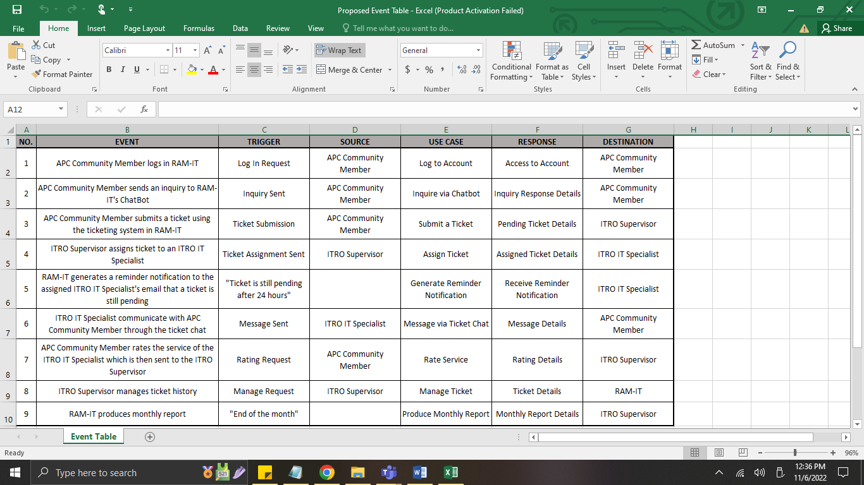

Table : Event Table

### Use Case Diagram

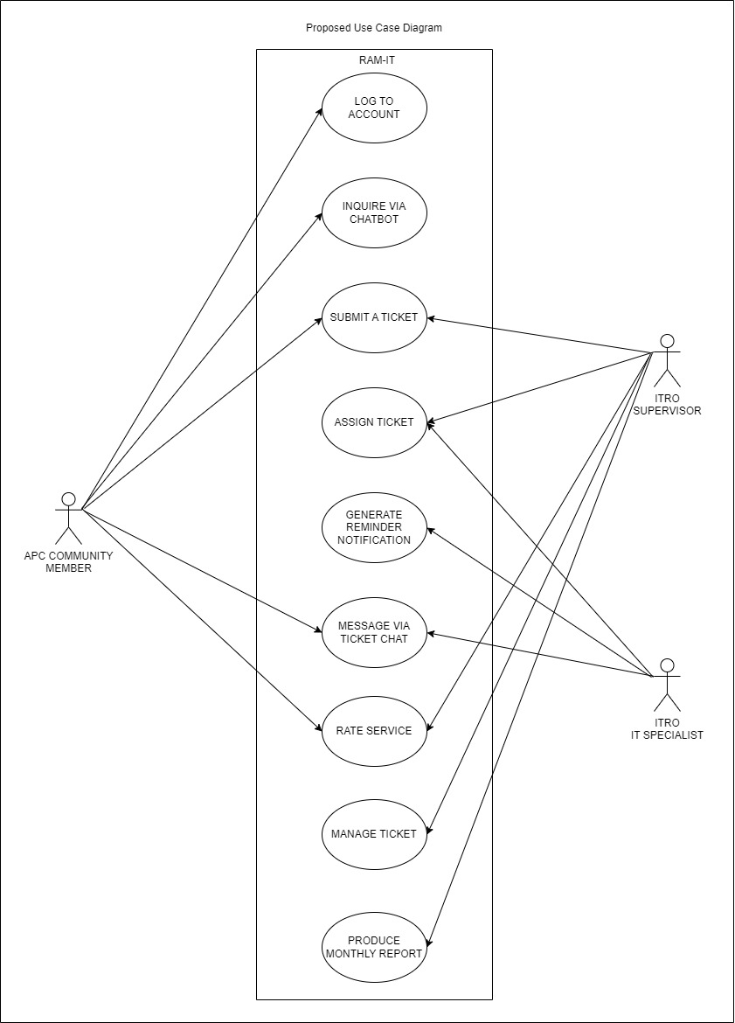

Figure : Use Case Diagram

### Use Case Full Description

|  |  |  |
| --- | --- | --- |
| **Use Case Name:** | Log to Account | |
| **Scenario:** | APC Community Member logs in RAM-IT | |
| **Triggering Event:** | Log in Request | |
| **Brief Description:** | A user or a part of APC community will login to RAM-IT to access its services. | |
| **Actors:** | APC Community Member | |
| **Related Use Cases:** | Inquire via ChatBot | |
| **Stakeholders:** | APC Community Member | |
| **Pre-conditions:** | User must have an office365 account | |
| **Post-conditions:** | User should have login to the email/ logout of the RAM-IT | |
| **Flow of Activities:** | **Actor** | **System** |
| 1. APC Community goes to the RAM-IT website 2. APC Community clicks login 3. APC Community login to RAM-IT | 1.1 RAM-IT shows login page  2.1 APC Community Inputs Email Username and password  3.1 System directs the user into the home page of RAM-IT |
| **Exception Conditions:** | 3.1 APC Community inputs wrong Email Username  3.2 APC Community inputs wrong password  3.3 APC Community does not input anything | |

Table : Use Case Full Description (Log In Account)

|  |  |  |
| --- | --- | --- |
| **Use Case Name:** | Inquire via ChatBot | |
| **Scenario:** | APC Community Member sends an inquiry to RAM-IT's ChatBot | |
| **Triggering Event:** | Inquiry Sent | |
| **Brief Description:** | A user in APC community will inquire a problem through the RAM-IT ChatBot | |
| **Actors:** | APC Community Member | |
| **Related Use Cases:** | Log to Account & Submit a Ticket | |
| **Stakeholders:** | APC Community Member | |
| **Pre-conditions:** | User must have an office365 account  User should have login into RAM-IT | |
| **Post-conditions:** | User should have sent an inquiry | |
| **Flow of Activities:** | **Actor** | **System** |
| 1. APC Community goes to the RAM-IT website 2. APC Community login to RAM-IT 3. A user in APC Community makes a new chat to chat with ChatBot about a problem that the user wants to be answered | 2.1 APC Community Inputs Email Username and password  2.2 System directs the user into the home page of RAM-IT  3.1 System creates a new chat for a new problem for the ChatBot to answer |
| **Exception Conditions:** | * 1. APC Community inputs wrong Email Username   2. APC Community inputs wrong password   3. APC Community does not input anything   4. APC Community got his problem answered previously in   the past  3.2 APC Community’s problem is new and unique thus  ChatBot recommends the user to make a ticket about the  problem | |

Table : Use Case Full Description (Inquire through ChatBot)

|  |  |  |
| --- | --- | --- |
| **Use Case Name:** | Submit a Ticket | |
| **Scenario:** | APC Community Member submits a ticket using the ticketing system in RAM-IT | |
| **Triggering Event:** | Ticket submission | |
| **Brief Description:** | If the user in APC community isn’t satisfied with the ChatBot’s answer they are recommended to make a ticket in the helpdesk/ticketing system of RAM-IT | |
| **Actors:** | APC Community Member | |
| **Related Use Cases:** | Log to Account, Assign Ticket, Message via Ticket Chat, & Manage Ticket | |
| **Stakeholders:** | APC Community Member & ITRO Supervisor | |
| **Pre-conditions:** | User must have an office365 account | |
| **Post-conditions:** | User should have login into RAM-IT | |
| **Flow of Activities:** | **Actor** | **System** |
| 1. APC Community goes to the RAM-IT website 2. APC Community login to RAM-IT 3. A user in APC Community makes a new chat to chat with ChatBot about a problem that the user wants to be answered 4. A user in APC Community creates a ticket while speaking to the ChatBot/ the ChatBot recommends putting up a ticket for the inquiry | 2.1 APC Community Inputs Email Username and password  2.2 System directs the user into the home page of RAM-IT  3.1 system creates a new chat for a new problem for the ChatBot to answer  4.1 system will create the ticket and give it a new ID |
| **Exception Conditions:** | * 1. APC Community inputs wrong Email Username   2. APC Community inputs wrong password   3. APC Community does not input anything   4. APC Community got his problem answered previously in   the past  3.2 APC Community’s problem is new and unique thus  ChatBot recommends the user to make a ticket about the  problem | |

Table : Use Case Full Description (Submit a Ticket)

|  |  |  |
| --- | --- | --- |
| **Use Case Name:** | Assign Ticket | |
| **Scenario:** | ITRO Supervisor assigns ticket to an ITRO IT Specialist | |
| **Triggering Event:** | Ticket Assignment Sent | |
| **Brief Description:** | The ITRO Supervisor receives pending ticket then assigns it to one of the ITRO IT Specialist who is most qualified to answer the ticket. | |
| **Actors:** | ITRO Supervisor | |
| **Related Use Cases:** | Log to Account, Submit a Ticket, Message via Ticket Chat, & Manage Ticket | |
| **Stakeholders:** | ITRO Supervisor & ITRO IT Specialist | |
| **Pre-conditions:** | Users should have submitted a ticket beforehand | |
| **Post-conditions:** | ITRO turns an active ticket to a closed ticket | |
| **Flow of Activities:** | **Actor** | **System** |
| 1. ITRO Supervisor clicks on new pending ticket 2. ITRO Supervisor assigns an ITRO IT Specialist | * 1. RAM-IT displays new pending ticket   2. RAM-IT will send the assigned ticket to the respective assigned ITRO IT Specialist |
| **Exception Conditions:** | 2.1. ITRO Supervisor rejects the ticket | |

Table : Use Case Full Description (Assign Ticket)

|  |  |  |
| --- | --- | --- |
| **Use Case Name:** | Generate Reminder Notification | |
| **Scenario:** | RAM-IT generates a reminder notification to both the ITRO Supervisor's email and assigned IT Specialist's email that a ticket is still pending | |
| **Triggering Event:** | "Ticket is still pending after 24 hours" | |
| **Brief Description:** | ITRO Supervisor and ITRO IT Specialist receives notification for escalation. | |
| **Actors:** | RAM-IT | |
| **Related Use Cases:** | Log to Account, Submit a Ticket, Assign Ticket, & Message via Ticket Chat | |
| **Stakeholders:** | ITRO Supervisor & ITRO IT Specialist | |
| **Pre-conditions:** | Users should have submitted a ticket beforehand | |
| **Post-conditions:** | ITRO sends replies from the active ticket | |
| **Flow of Activities:** | **Actor** | **System** |
| 1. New assigned ticket is sent to ITRO IT Specialist 2. ITRO IT Specialist and Supervisor receives reminder notification | * 1. RAM-IT monitors the new assigned ticket   2. RAM-IT send a reminder notification if ticket is still pending within 24 hours |
| **Exception Conditions:** | * 1. Ticket is still pending for another 24 hours | |

Table : Use Case Full Description (Generate Reminder Notification)

|  |  |  |
| --- | --- | --- |
| **Use Case Name:** | Message via Ticket Chat | |
| **Scenario:** | ITRO IT Specialist communicate with APC Community Member through the ticket chat | |
| **Triggering Event:** | Message Sent | |
| **Brief Description:** | ITRO IT Specialist provides service with APC Community Member through chatting in the ticket chat | |
| **Actors:** | ITRO IT Specialist | |
| **Related Use Cases:** | Log to Account, Submit a Ticket, Assign Ticket, Generate Reminder Notification, & Manage Ticket | |
| **Stakeholders:** | APC Community & ITRO IT Specialist | |
| **Pre-conditions:** | There should be a pending ticket | |
| **Post-conditions:** | ITRO IT Specialist gains more knowledge about a certain issue | |
| **Flow of Activities:** | **Actor** | **System** |
| 1. ITRO Supervisor chats APC Community Member 2. APC Community member chats ITRO IT Specialist after receiving response | * 1. RAM-IT Monitors the ticket chat |
| **Exception Conditions:** | * 1. APC Community Member does not chat within a week | |

Table : Use Case Full Description (Messaging via Ticketing Chat)

|  |  |  |
| --- | --- | --- |
| **Use Case Name:** | Rate Service | |
| **Scenario:** | APC Community Member rates the service of the ITRO IT Specialist which is then sent to the ITRO Supervisor | |
| **Triggering Event:** | Rating Request | |
| **Brief Description:** | APC Community Member rates the service that the ITRO IT Specialist provided | |
| **Actors:** | APC Community Member | |
| **Related Use Cases:** | Log to Account, Message via Ticket Chat, & Manage Ticket | |
| **Stakeholders:** | APC Community Member, ITRO IT Specialist, & ITRO Supervisor | |
| **Pre-conditions:** | There should be closed ticket in the past | |
| **Post-conditions:** | ITRO views ticket history | |
| **Flow of Activities:** | **Actor** | **System** |
| 1. APC Community Member requests for rating prompt after confirming their satisfaction 2. ITRO Supervisor verifies request | * 1. RAM-IT Sends request to ITRO Supervisor   2.1. RAM-IT sends rating prompt to APC Community Member |
| **Exception Conditions:** | * 1. APC Community Member does not request rating prompt. | |

Table : Use Case Full Description (Rate Service)

|  |  |  |
| --- | --- | --- |
| **Use Case Name:** | Manage Ticket | |
| **Scenario:** | ITRO Supervisor manages ticket history | |
| **Triggering Event:** | Manage Request | |
| **Brief Description:** | ITRO Supervisor will manage the current open tickets & ticket history in the database. | |
| **Actors:** | ITRO Supervisor | |
| **Related Use Cases:** | Log to Account, Submit a Ticket, Assign Ticket, Message via Ticket Chat, & Generate Reminder Notification | |
| **Stakeholders:** | ITRO Supervisor, ITRO IT Specialist, & APC Community Member | |
| **Pre-conditions:** | There should be a ticket that should be sent to the ITRO | |
| **Post-conditions:** | System sends a notification to the ITRO | |
| **Flow of Activities:** | **Actor** | **System** |
| 1. Rating from APC Community Member is received by the ITRO Supervisor 2. ITRO Supervisor closes the ticket 3. ITRO Supervisor filters ticket history by accounts 4. ITRO Supervisor clicks on closed ticket | * 1. RAM-IT monitors ticket status   2. RAMI-IT closes ticket   3. RAM-IT filters ticket history by account   4. RAM-IT displays ticket history list   5. RAM-IT displays closed ticket history |
| **Exception Conditions:** | 3.1. ITRO Supervisor does not request for filtering  4.1. ITRO does not click any closed ticket history | |

Table :Use Case Full Description (Manage Ticket)

|  |  |  |
| --- | --- | --- |
| **Use Case Name:** | Produce Monthly Report | |
| **Scenario:** | RAM-IT produces monthly report | |
| **Triggering Event:** | “End of the month” | |
| **Brief Description:** | In the end of every month the system would release both a general and an individual monthly report | |
| **Actors:** | RAM-IT | |
| **Related Use Cases:** | Log to Account & Manage Ticket | |
| **Stakeholders:** | RAM-IT | |
| **Pre-conditions:** | There should be an activity that is note for a notification of the system (Five Ticket Requests are accumulated from a user) | |
| **Post-conditions:** | System sends a notification to the ITRO | |
| **Flow of Activities:** | **Actor** | **System** |
| 1. The system will produce a monthly report | 1.1 At the end of the month the system would generate a monthly report from the traffic that was recorded within the month  1.2 At the end of the month the system would generate a monthly report from the tickets that was closed by an individual of the ITRO that was recorded within the month |
| **Exception Conditions:** | 1.1 ITRO manually generates the monthly report before the  end of the month | |

Table :Use Case Full Description (Produce Monthly Report)

## Gap Analysis

|  |  |  |  |
| --- | --- | --- | --- |
| Product Backlog ID | Current System | Proposed Changes | Impact |
| 1 | Log In using Outlook | Log In to the website using Microsoft account | There is no impact, the proposed system still uses the Microsoft accounts to log in on the website |
| 2 | Log In using Outlook as an APC community | Log In to the website using the APC community Microsoft account | There is no impact on the APC community, the proposed system still uses the Microsoft accounts to log in to the website |
| 3 | Log In using Outlook as an ITRO or an ITRO personnel | Log In to the website using the ITRO Microsoft account | There is no impact on the ITRO, the proposed system still uses the Microsoft accounts to log in to the website |
| 4 | Send an email to either of APC community or ITRO using Outlook | Chat bot for immediate and simple responses | Instead of emailing and waiting for a response from the ITRO, for simple inquiries and immediate responses, the APC community will use the Chat Bot |
| 5 | Replies to the email sent by the APC community using Outlook | Chat Bot is the presence of ITRO for immediate responses to simple inquiries | Instead of emailing and waiting for a response from the ITRO, for simple inquiries and immediate responses, the APC community will use the Chat Bo |
| 6 | Sends an email to the ITRO using Outlook | APC community uses Chat Bot for immediate responses to their simple inquiries | Instead of emailing and waiting for a response from the ITRO, for simple inquiries and immediate responses, the APC community will use the Chat Bo |
| 7 | Send an email using an Outlook | A ticketing system for unsolved inquiries and in-depth responses | Instead of sorting the emails that consist of inquiries in the ITRO’s Outlook email, a website will be made where inquiries are stored and may use to communicate with the ITRO |
| 8 | Have a conversation using an Outlook email | A chat system between the APC community and ITRO in the ticketing system | Instead of the email which is a little bit confusing to have a conversation with, inside the ticketing system, there will be a chat room |
| 9 | Ignored or piled up an email | The ticket will be closed by the ITRO after the APC community’s verification  If the ticket wasn’t verified by the APC community, the ticket will automatically close after 1 week | To easily assist and settle the inquiries properly there will be a close ticket feature to determine if an inquiry is settled or not and be stored in the system. |
| 10 | View an email | Open or closed tickets can be viewed on the website | Instead of reading and reviewing plenty of emails because of conversations, read and review the chat room instead. |
| 11 | Notification sent through the Outlook website or Outlook application or software | A notification system that has a trigger to send a notification to the ITRO’s email  (5 Tickets = 1 Notification) | An impact for the ITRO to reduce the received notification on the ITRO’s email  A 1 notification email will be sent for the ITRO to respond to the tickets if the tickets reach 5 tickets. |
| 12 | Using the search bar to look for specific emails or email addresses in Outlook | Using the search bar of the website to find tickets and/or email addresses on ITRO’s side | To able, the ITRO determine how many inquiries were sent by the APC community |
| 13 | No current system for the monthly report for inquiries | Once the website reached 1 month, the system automatically sends a monthly report of tickets to ITRO | Closed tickets for a month will have a report where the ITRO will review the tickets  If the tickets that were inquired about and solved are new, they will be added to the database where the chat bot will get its answers |
| 14 | Using the search bar to look for specific emails | Using the search bar of the website to find tickets and/or email addresses on ITRO’s side | To able, the ITRO determine the history of the APC community’s tickets. |
| 15 | Emails consist of inquiries are stored in the ITRO’s Outlook email | The website that stores the APC community’s tickets consists of inquiries | Instead of using the ITRO Outlook to email that bombards and piled up important emails, a website is created for the APC community’s inquiries to the ITRO |
| 16 | Have a conversation using the Outlook email of ITRO | A chat system between the APC community and ITRO in the ticketing system | Instead of the email which is a little bit confusing to have a conversation with, inside the ticketing system there will be a chat room between the APC community and ITRO, where ITRO can respond |
| 17 | Ignored or piled up an email on ITRO’s outlook | The ticket will be closed by the ITRO after the APC community’s verification  If the ticket wasn’t verified by the APC community, the ticket will automatically close after 1 week | To easily assist and settle the inquiries properly there will be a close ticket feature to determine if an inquiry is settled or not and be stored in the system.  The close tickets will be used for the chat bot updates. |
| 18 | View an Email using ITRO’s outlook | Open or closed tickets can be viewed on the website | Instead of reading and reviewing plenty of emails because of conversations, read and review the chat room instead by the ITRO |
| 19 | Notification sent through the Outlook website or Outlook application or software of ITRO | A notification system that has a trigger to send a notification to the ITRO’s email  (5 Tickets = 1 Notification) | An impact for the ITRO to reduce the received notification on the ITRO’s email  A 1 notification email will be sent for the ITRO to respond to the tickets, if the tickets reach 5 tickets. |
| 20 | Using the search bar to look for specific emails or email addresses in the ITRO’s Outlook | Using the search bar of the website to find tickets and/or email addresses on ITRO’s side | To able, the ITRO determine how many inquiries were sent by the APC community |
| 21 | No current system for the monthly report for inquiries | Once the website reached 1 month, the system automatically sends a monthly report of tickets to ITRO | Closed tickets for a month will have a report where the ITRO will review the tickets  If the tickets that were inquired about and solved are new, they will be added to the database where the chat bot will get its answers |
| 22 | Using the search bar to look for specific emails or email addresses in the ITRO’s Outlook | Using the search bar of the website to find tickets and/or email addresses on ITRO’s side | Instead of using the ITRO Outlook to email that bombards and piled up important emails, a website is created for the APC community’s inquiries to the ITRO |
| 23 | APC community will email ITRO through Outlook | APC community may use the ticketing system to create a ticket | Instead of emailing the APC community may submit a ticket as an effective way of asking for assistance from the ITRO regarding their inquiry  APC community may know if their ticket is still pending, open, or closed |
| 24 | APC community will have a conversation with the ITRO via email using Outlook | APC community may have a conversation with the ITRO on the ticketing system | Instead of the email which is a little bit confusing to have a conversation, inside the ticketing system, there will be a chat room between the APC community and ITRO, where the APC community can inquire |
| 25 | Using the search bar to look for specific emails or email addresses in the APC community’s Outlook | APC community can view their pending, open, or ticket history on the website | Instead of using Outlook to find inquiries, a website is created for the APC community to review and look for their tickets that consists of inquiries |
| 26 | Notification sent through the Outlook website or Outlook application or software of the APC community | A notification will be sent to the APC community’s Outlook email for ticket updates | There is no change in the notification system of the APC community, they will still receive a notification to their Outlook email that will be coming from the website |
| 27 | ITRO controls the security of the Microsoft Accounts | ITRO controls the security of the accounts  Developers will maintain, or update the website | ITRO has full control of the accessibility of the website where their system can be updated regarding inquiries to make the assistance that is needed by the APC community effective and efficient |

Table : Gap Analysis

## System Analysis and Design

### Context Diagram

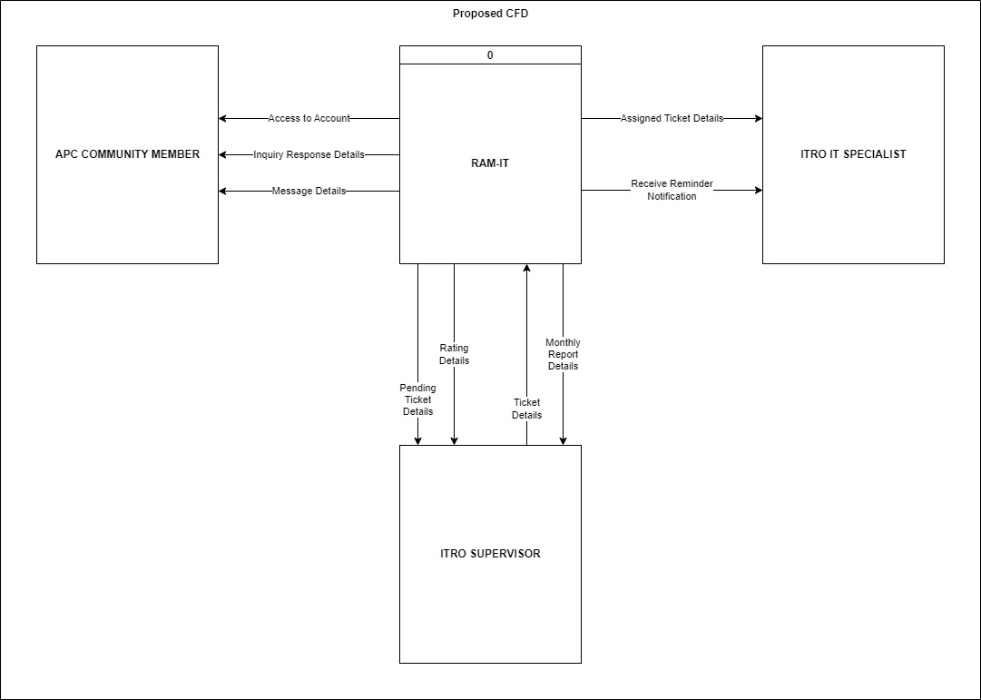

Figure : Context Diagram

### Data Flow Diagrams

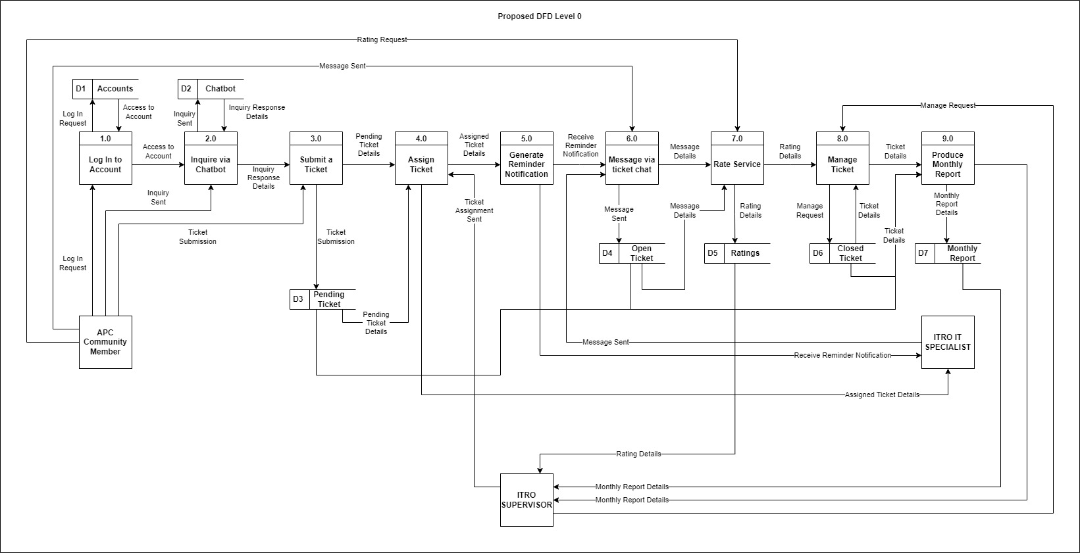

Figure : Data Flow Diagrams (Level 0)

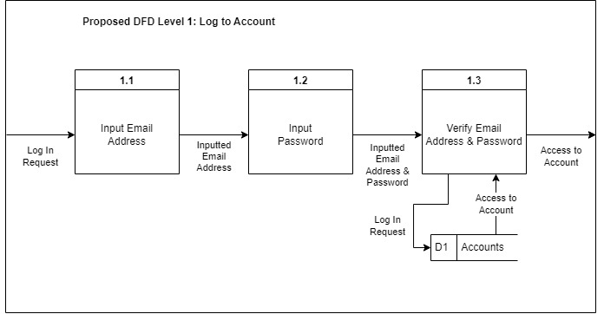

Figure : Proposed DFD Level 1: Log to Account

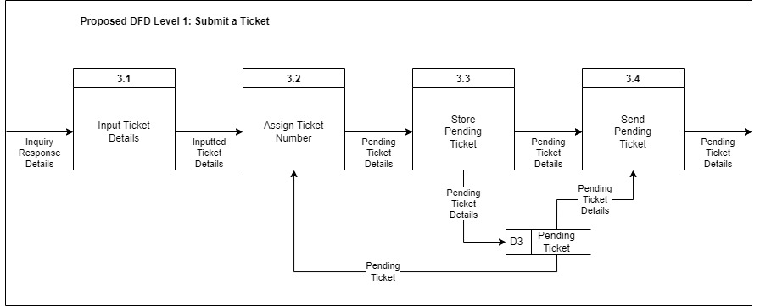

Figure : Proposed DFD Level 1: Submit a Ticket

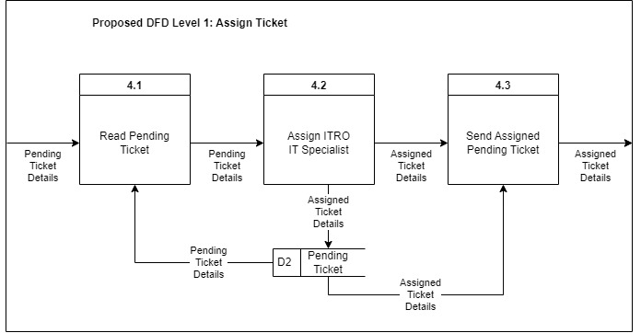

Figure : Proposed DFD Level 1: Assign Ticket

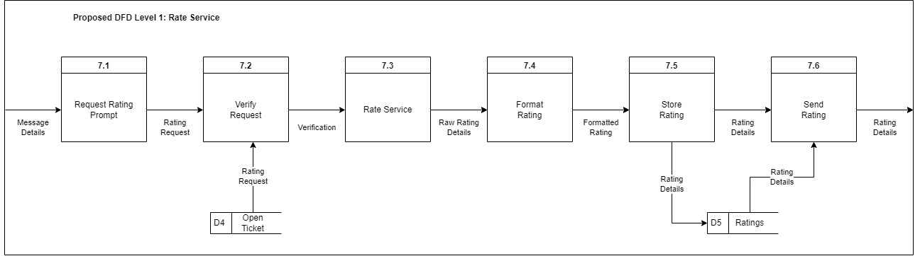

Figure : Proposed DFD Level 1: Rate Service

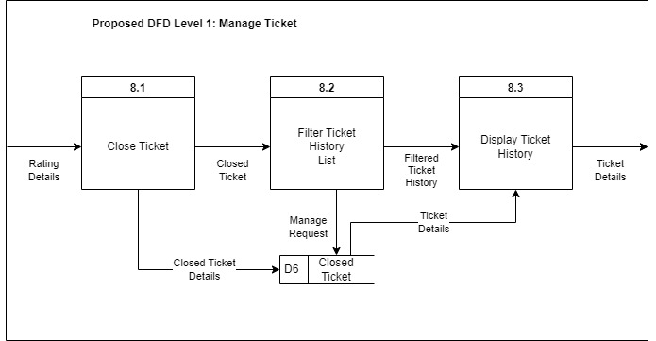

Figure : Proposed DFD Level 1: Manage Ticket

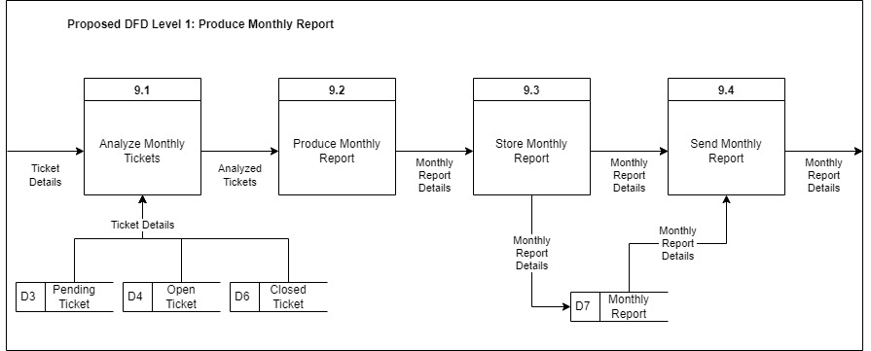

Figure : Proposed DFD Level 1: Produce Monthly Report

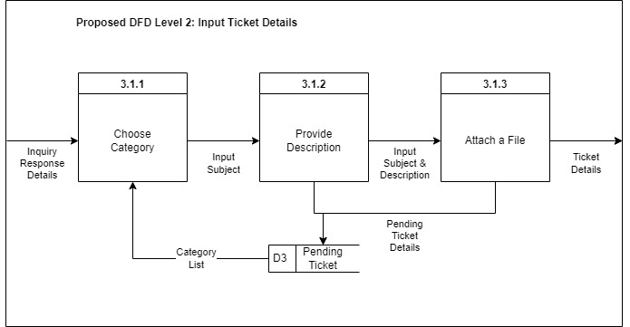

Figure : Proposed DFD Level 2: Input Ticket Details

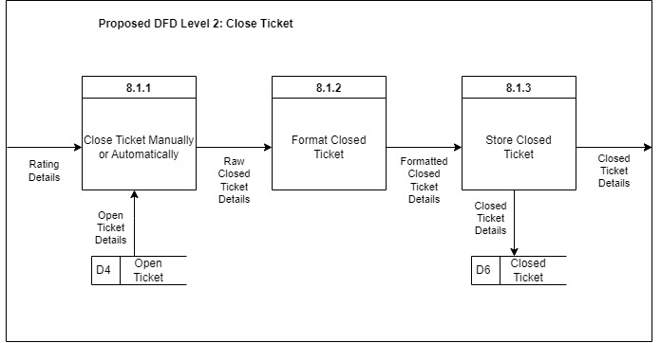

Figure : Proposed DFD Level 2: Closed Ticket

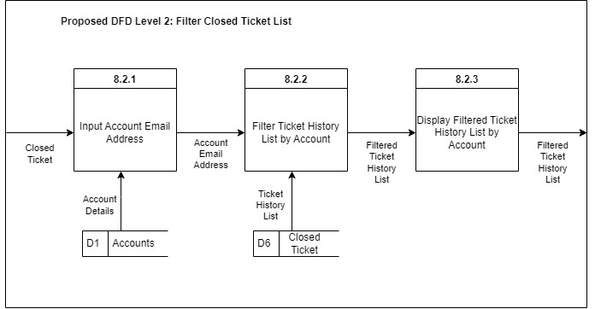

Figure : Proposed DFD Level 2: Filter Closed Ticket List

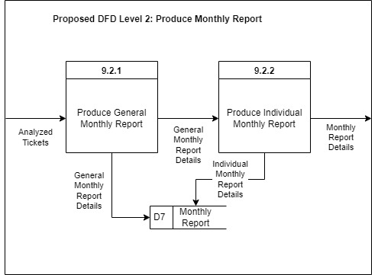

Figure : Proposed DFD Level 2: Produce Monthly Report

### Entity-Relationship Diagrams

Figure : Entity-Relationship Diagram

### Activity Diagrams

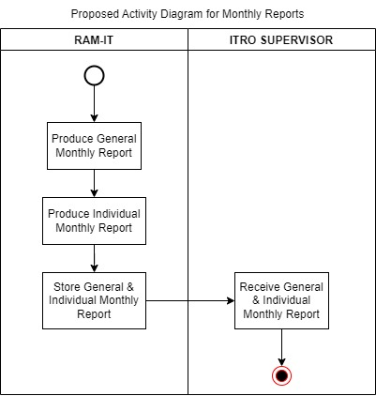

Figure : Activity Diagrams (Monthly Report)

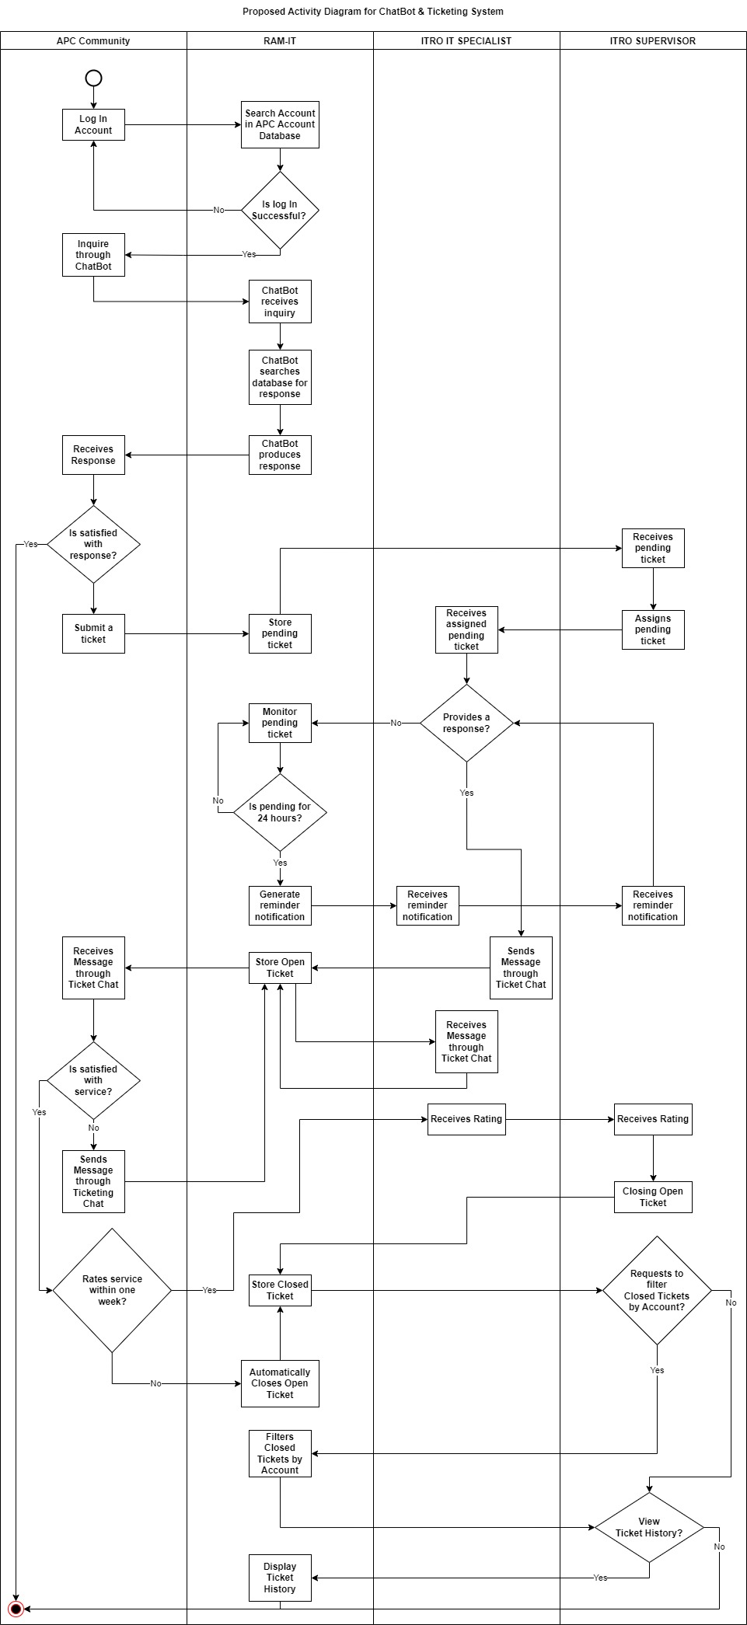

Figure : Activity Diagrams (ChatBot & Ticketing System) Part 1



Figure : Activity Diagrams (ChatBot & Ticketing System) Part 2

### Object Diagrams

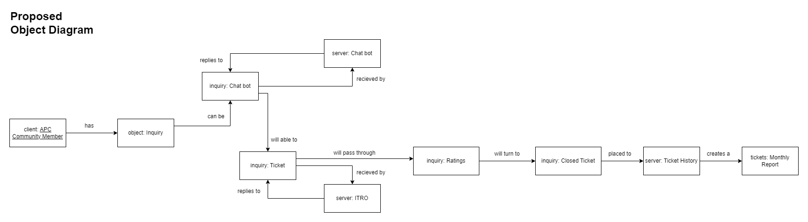

Figure : Object Diagram

### Class Diagrams

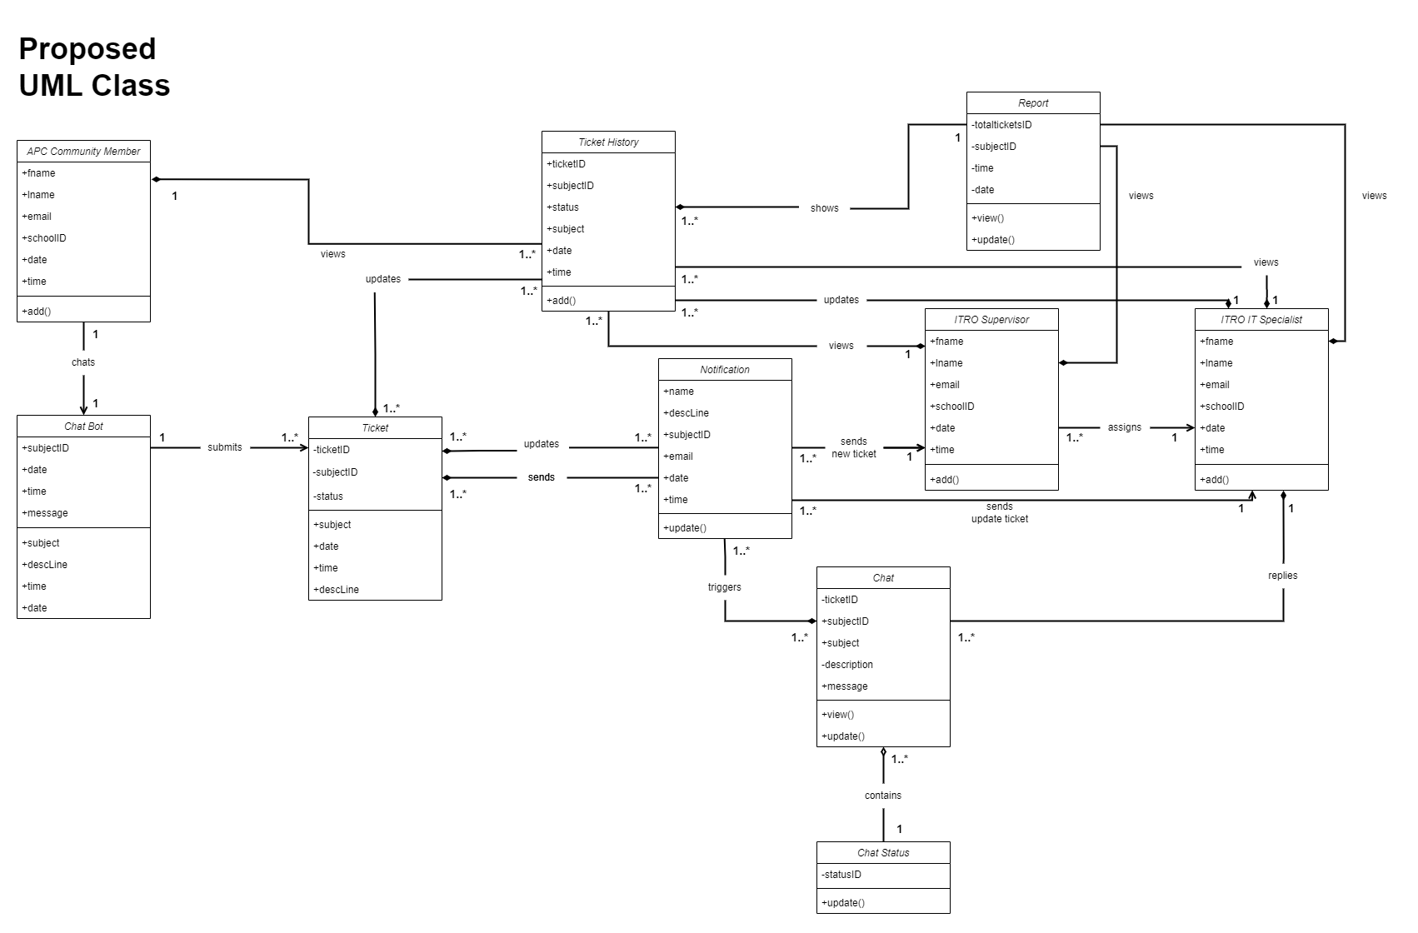

Figure : Class Diagram

### Sequence Diagrams

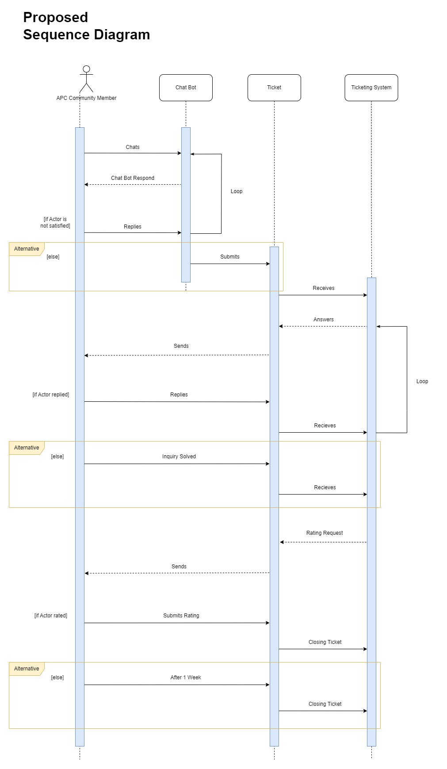

Figure : Proposed Sequence Diagram

### Package Diagram

Figure : Package Diagram

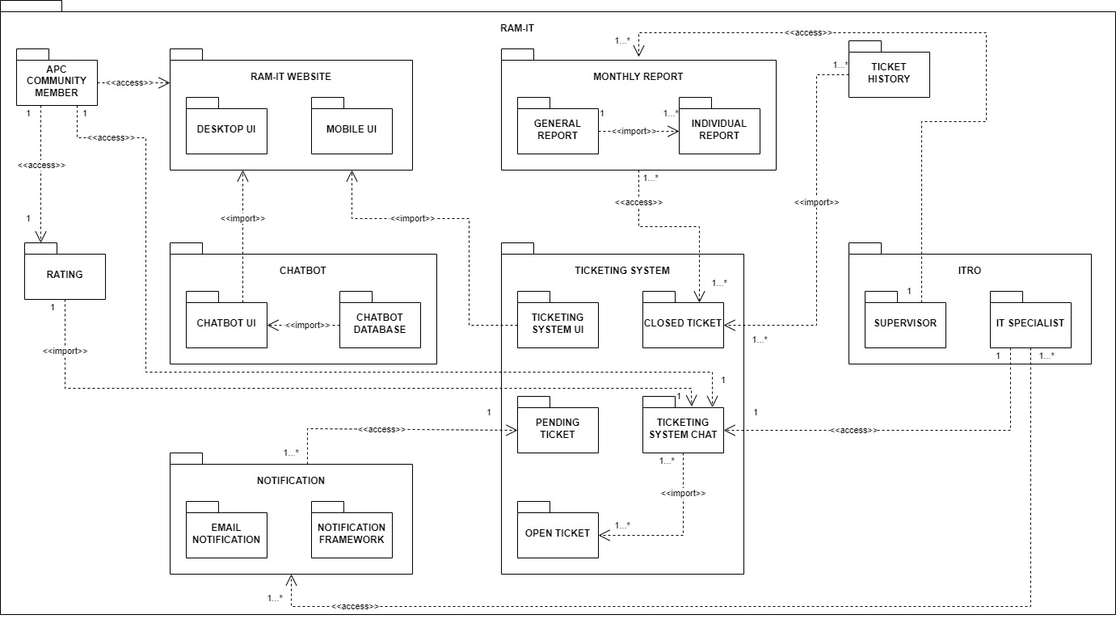

### Component Diagram

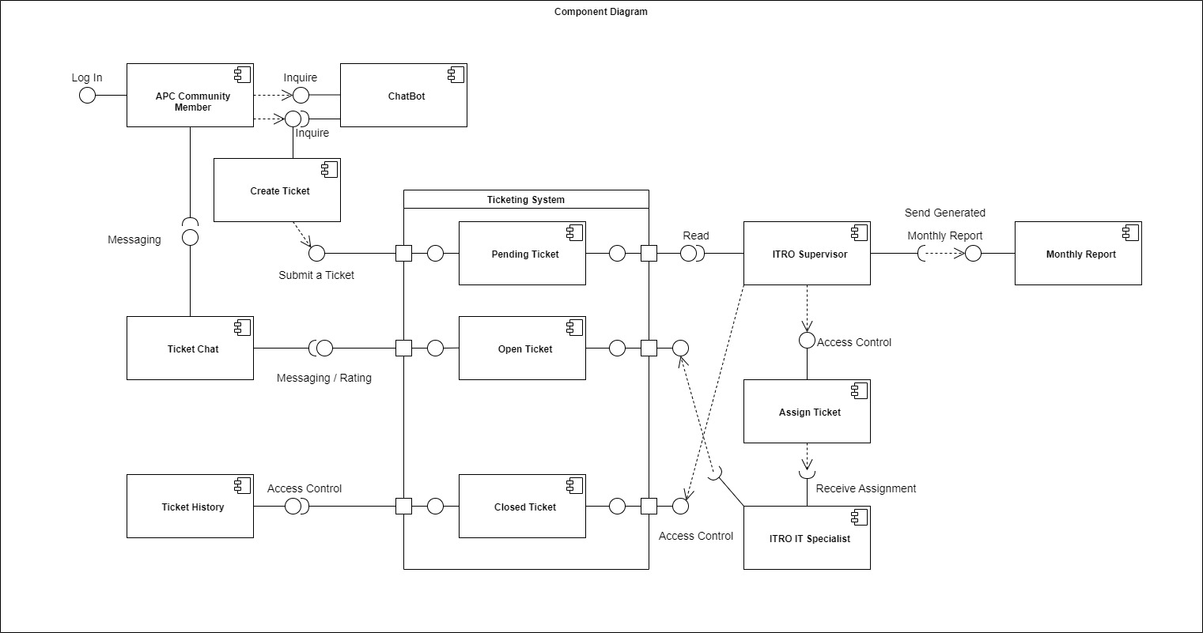

Figure : Component Diagram

### Deployment Diagram

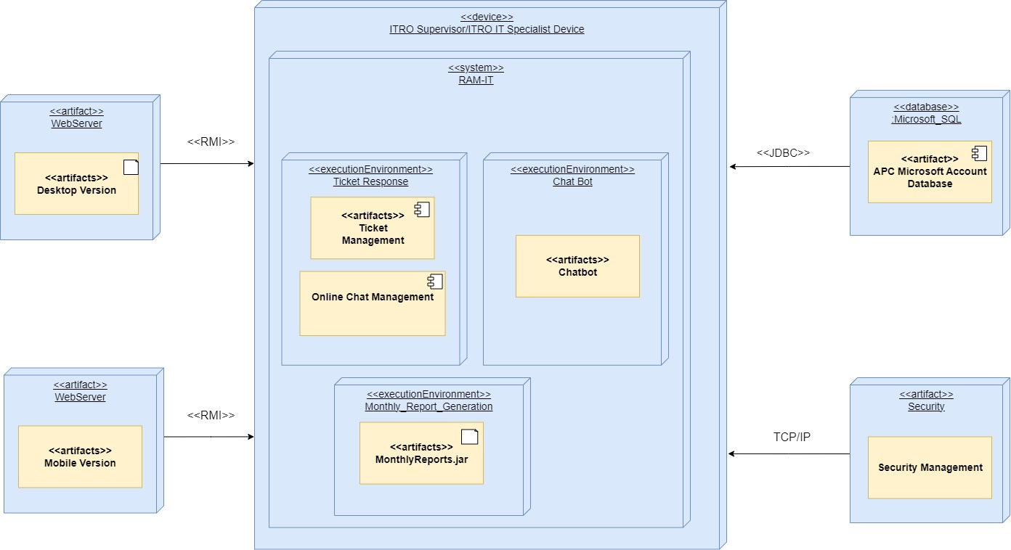

Figure : Deployment Diagram

### Machine State Diagram

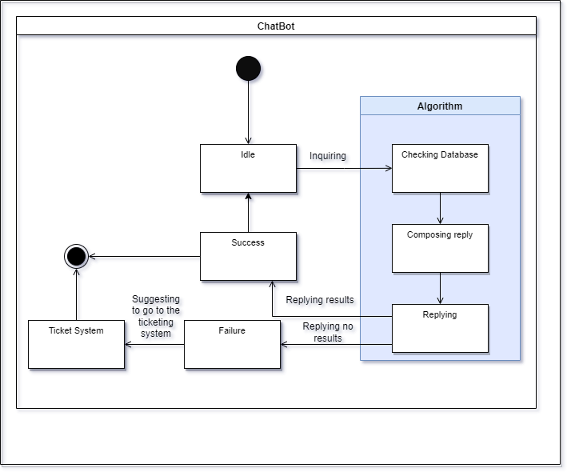

Figure : Machine State Diagram (Chatbot)

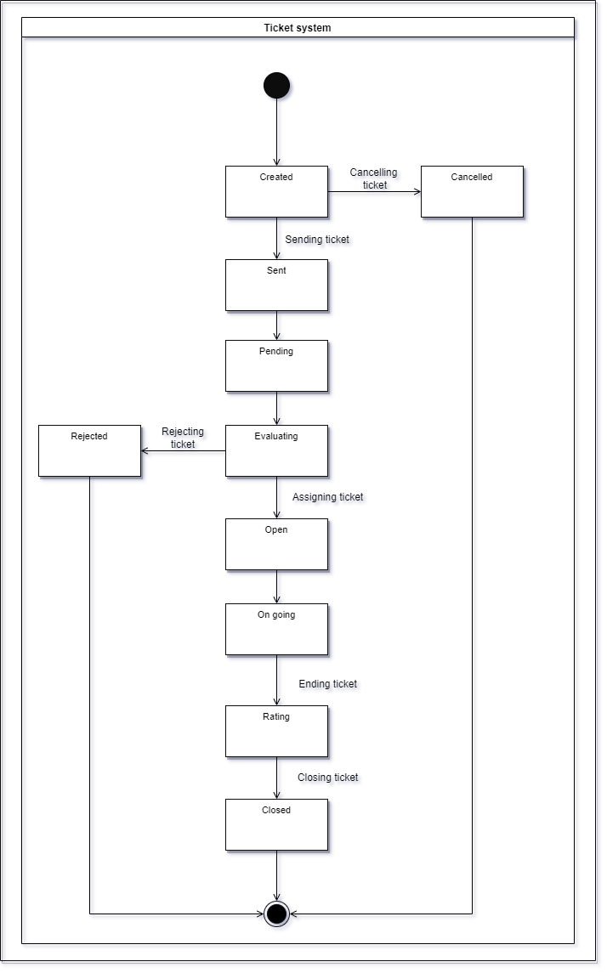

Figure : Machine State Diagram (Ticketing System)

# Results and Discussions

This section talks about the release plan of the proposed system as well as the mock-up & user classes and their characteristics.

## 5.1 Release Plan

|  |
| --- |
| **June 2022**  **Milestone 1**   * Wireframe   June 22, 2022 |

**Release 1**

* User can visualize the website
* User will know how the website work
* User will know the flow of the website
* User can visualize the features of the website

|  |
| --- |
| **September 2022**  **Milestone 2**   * Log In   **Milestone 3**   * Website blueprint * Website UI |

**Release 2**

* User can login
* User can see their identity
* User can view the website
* User can view the website’s UI design

|  |
| --- |
| **November 2022**  **Milestone 4**   * Ticketing System * Chat System * Notification |

**Release 3**

* User can experience the Ticketing System
* User can experience chat system
* User can be notified

|  |
| --- |
| **January 2023**  **Milestone 5**   * Open / Close Tickets * Ticket History * Generate Reports |

**Release 4**

* User can view and reply to open tickets
* User can close tickets
* User can review closed tickets
* User in the server side can filter accounts in the closed tickets
* User can see their ticket history
* User can update the database using the generated reports

|  |
| --- |
| **March 2023**  **Milestone 6**   * Chat Bot |

**Release 5**

* User can use chat bot
* Chat bot will answer based on the database

Figure : Release Plan

## 5.2 Mock-Up

Client Side

Figure : Log In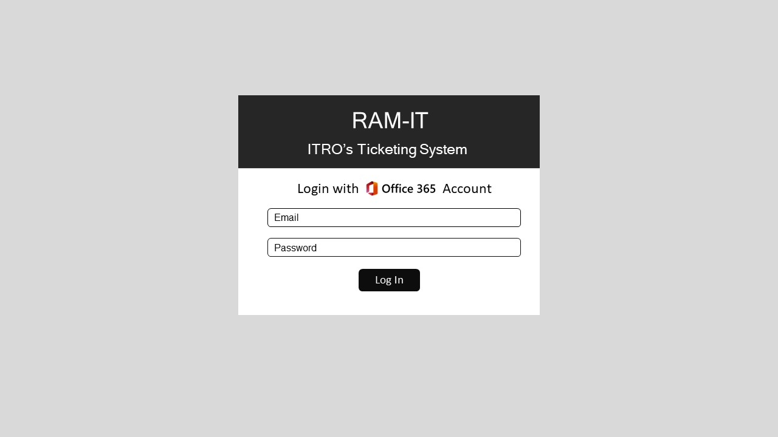 (Client)

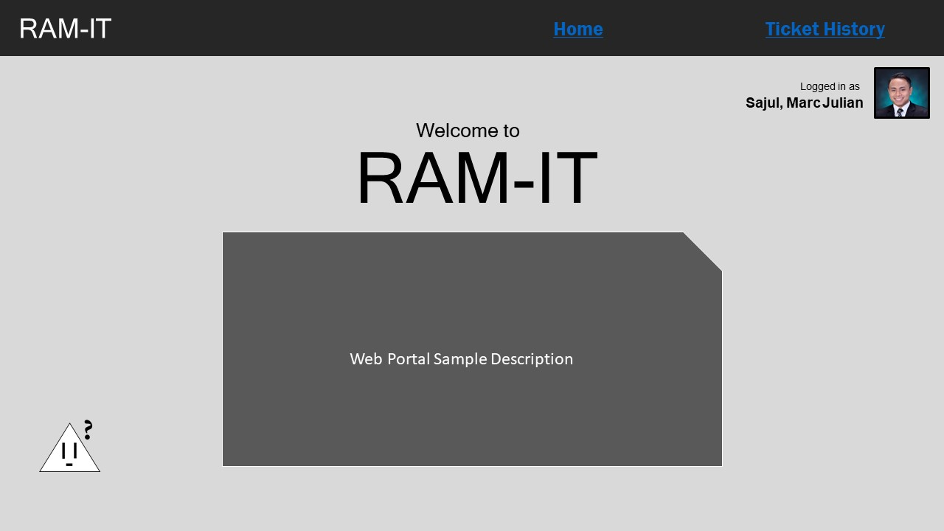

Figure : Home Part 1 (Client)

Figure : Home Part 2 (Client)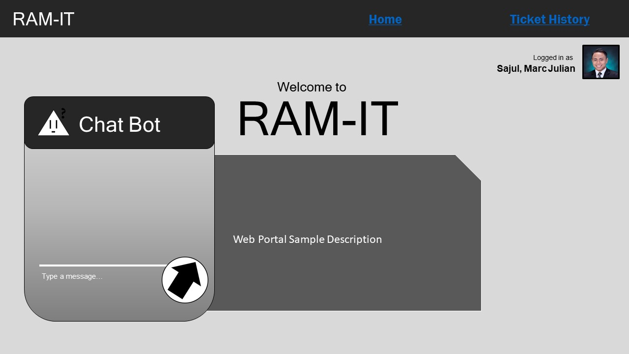

Figure : Home Part 3 (Client)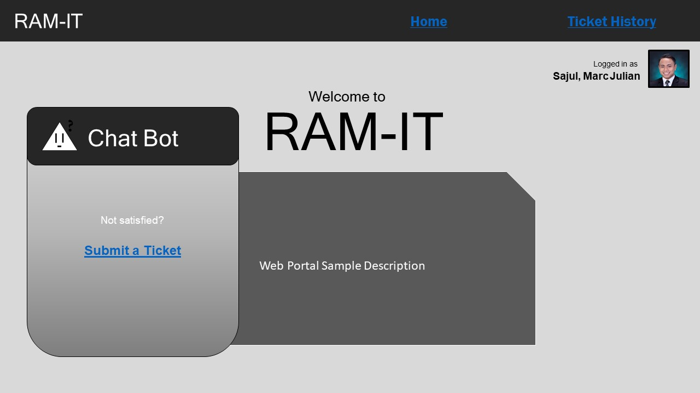

Figure : Ticket History Part 1 (Client)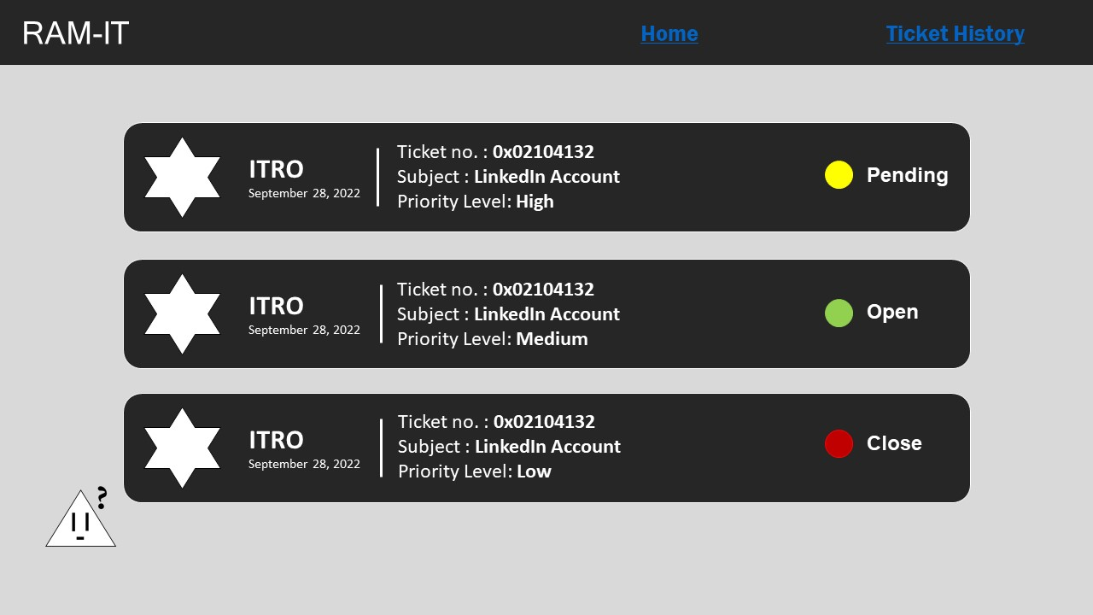

Figure : Ticket History Part 2 (Client)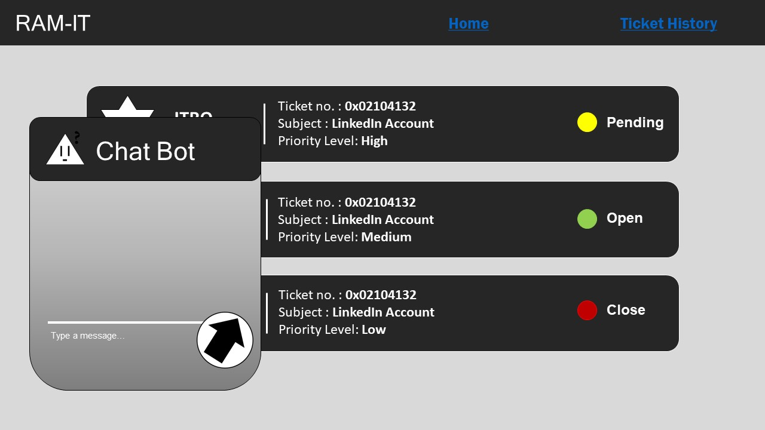

Figure : Ticket History Part 3 (Client)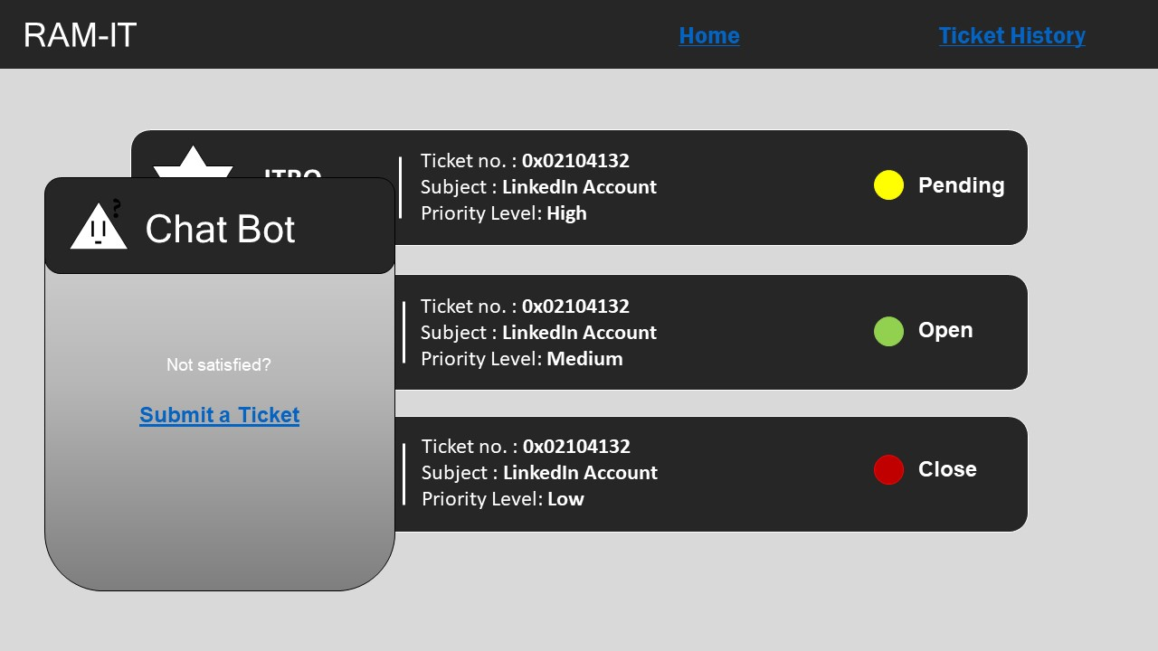

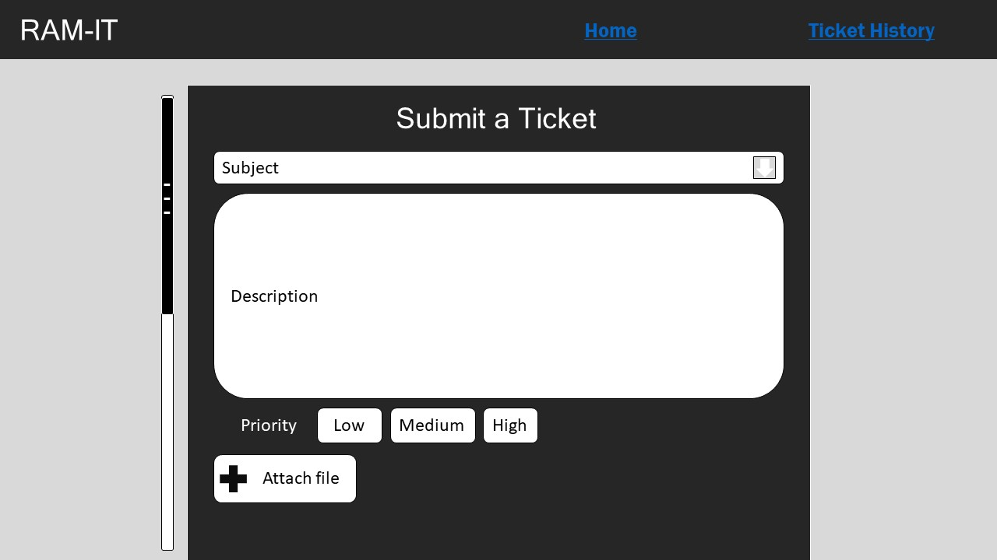

Figure : Ticket Request Template (Client)

Figure : Ticket Chatbox Open (Client)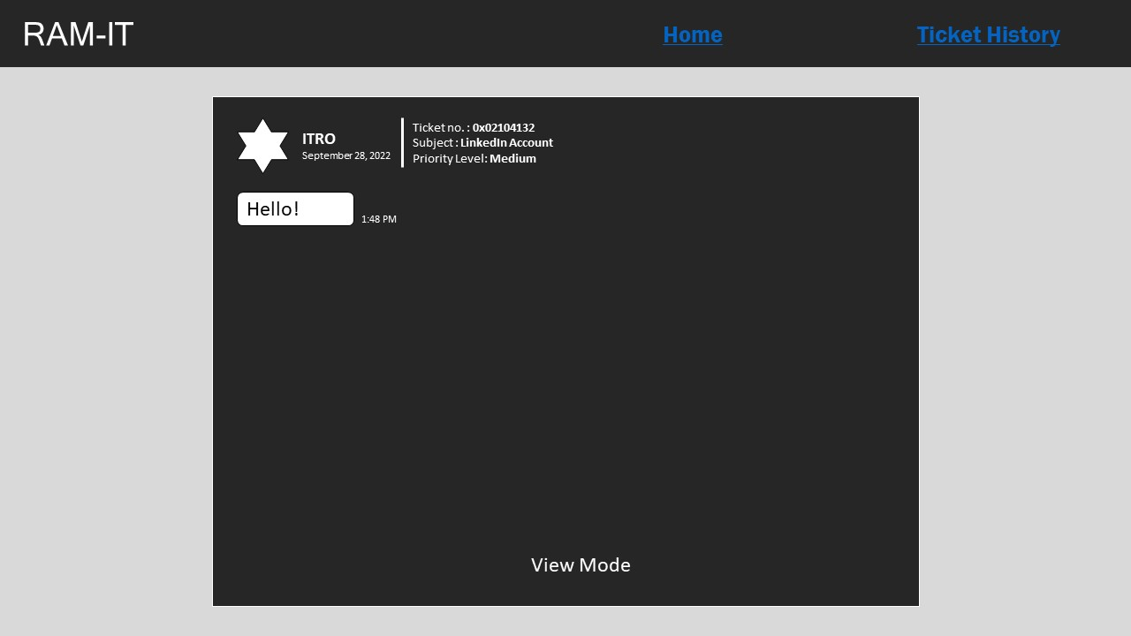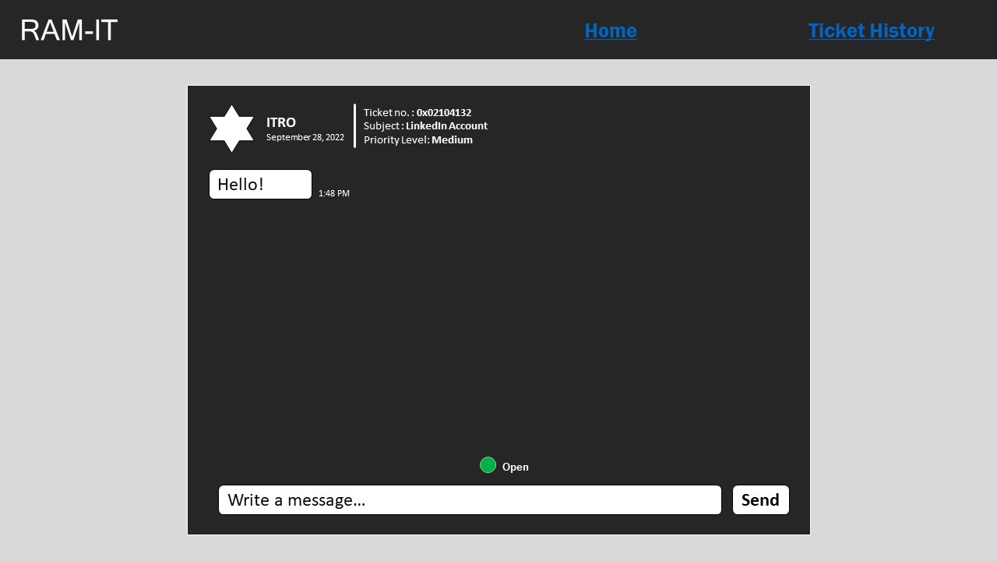

Figure : Ticket Chatbox Closed (Client)

Server Side

Figure : Log In (ITRO)

Figure : Home (ITRO)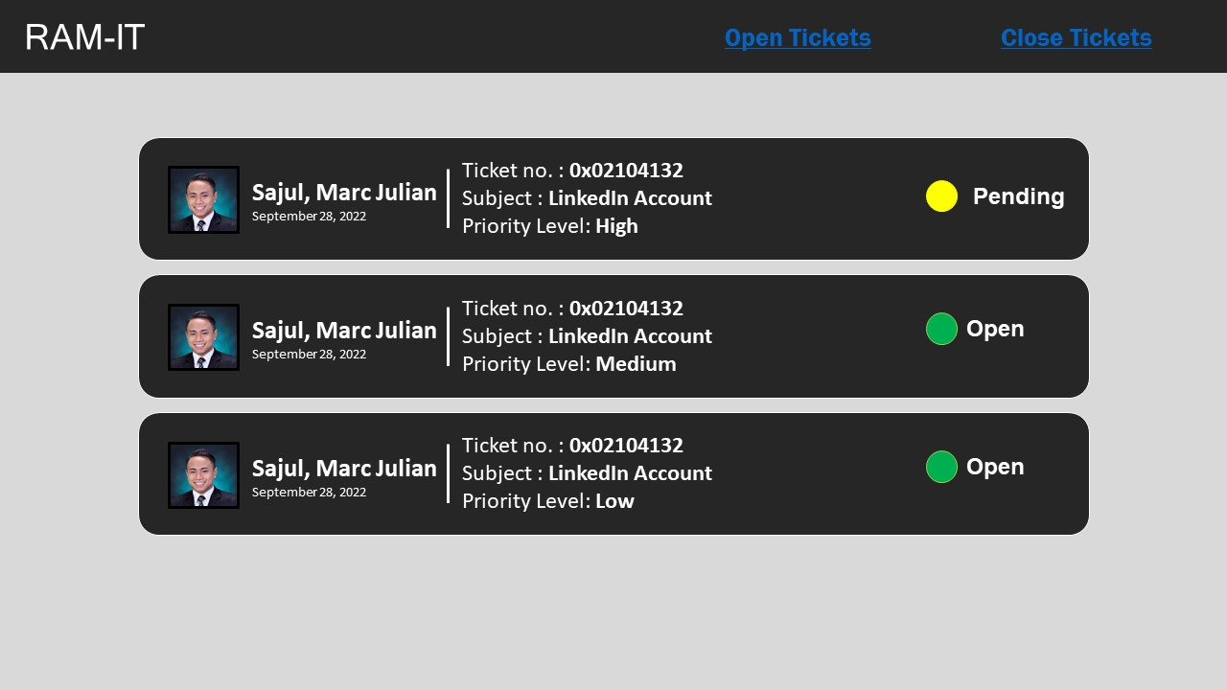

Figure : Ticket Chatbox (ITRO)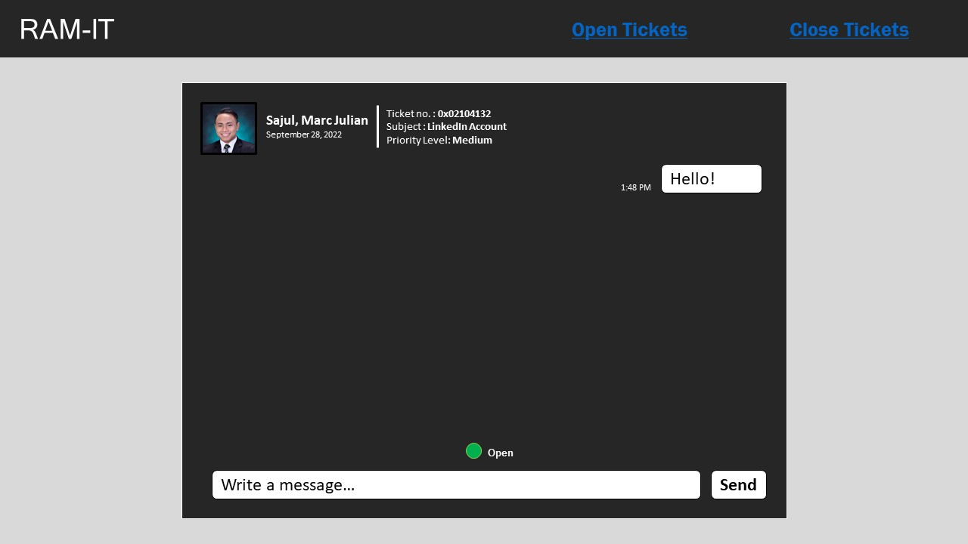

Figure : Ticket History (ITRO)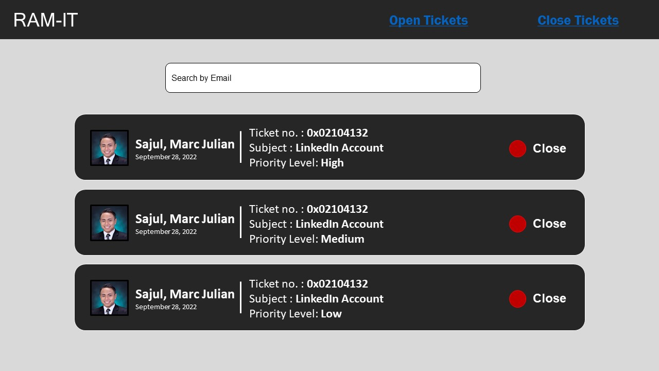

Figure : Ticket Chatbox Closed (ITRO)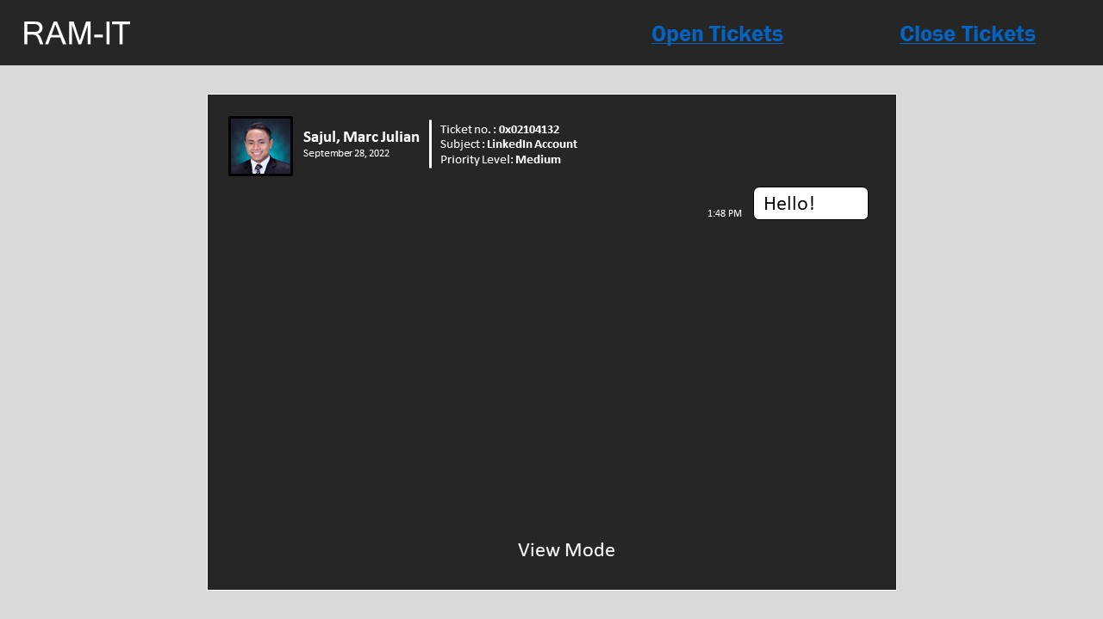

## 5.3 Prototype

APC COMMUNITY MEMBER

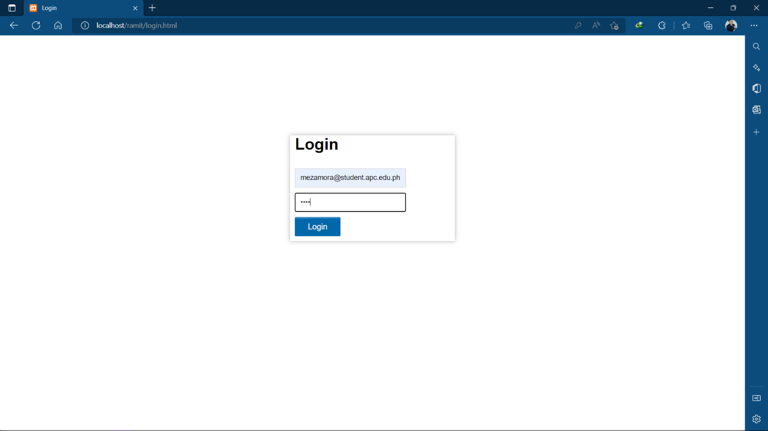

Figure : Login (Student/ITRO/Supervisor)

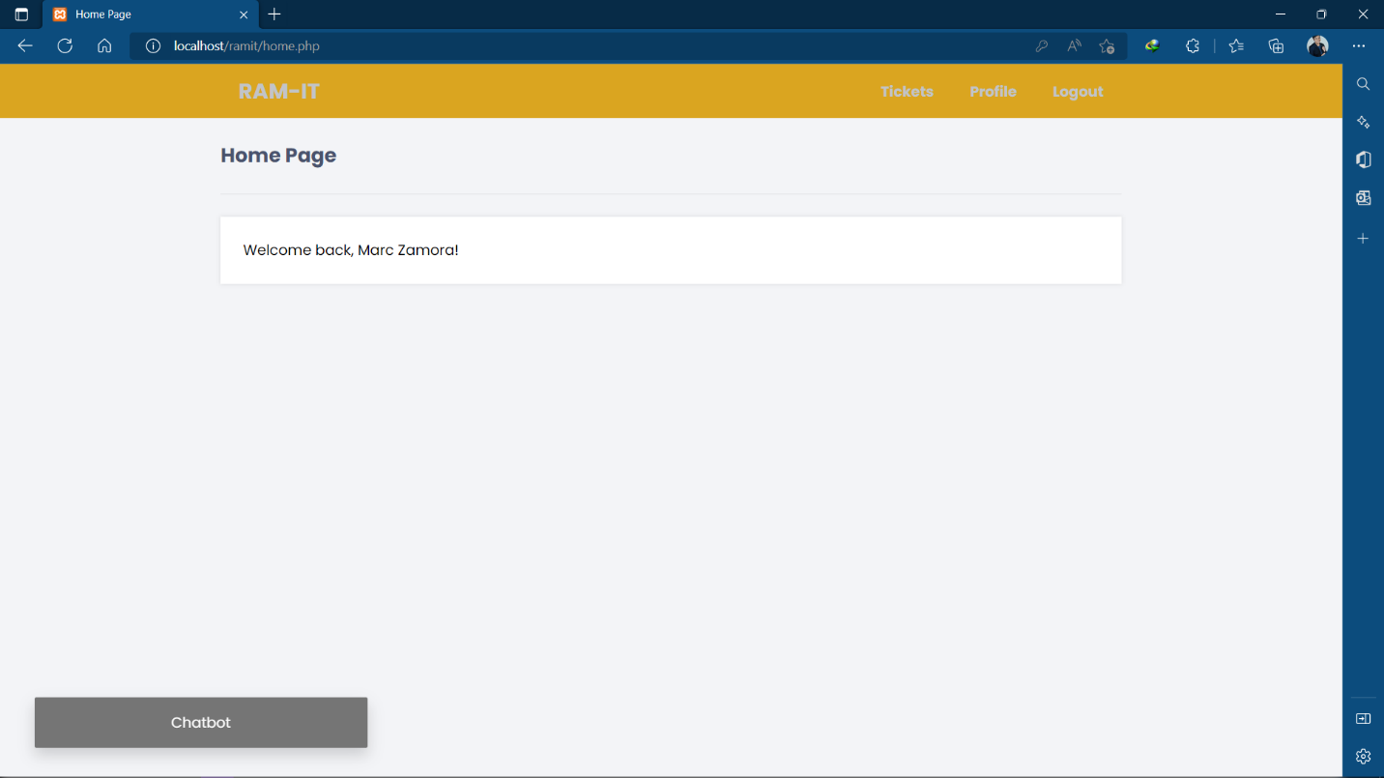

Figure : Home Page (Student)

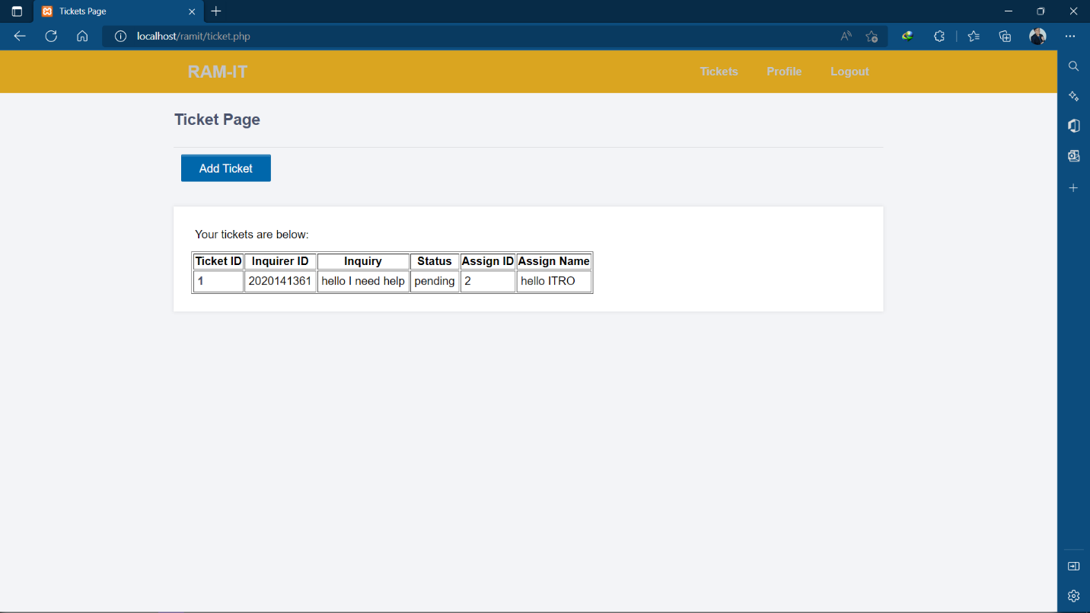

Figure : Tickets Page (Student)

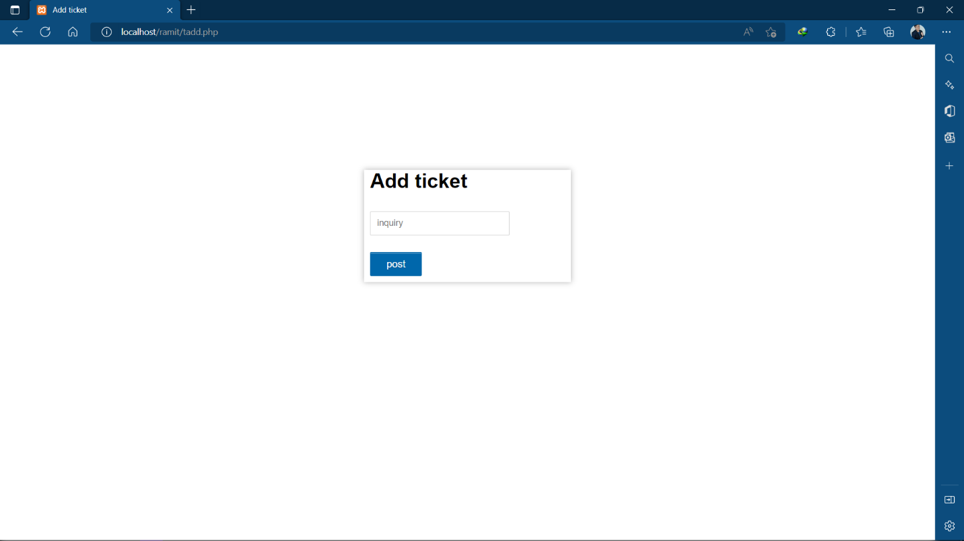

Figure : Add Ticket (Student)

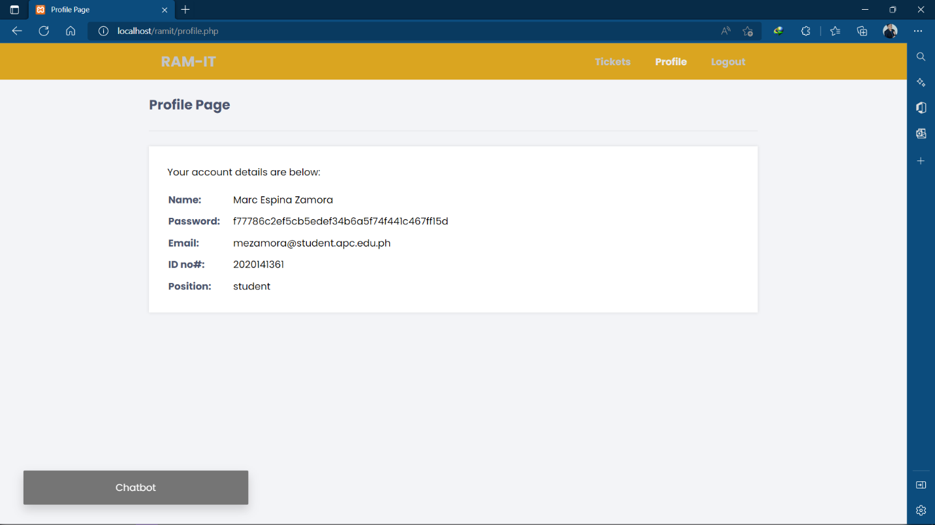

Figure : Profile (Student)

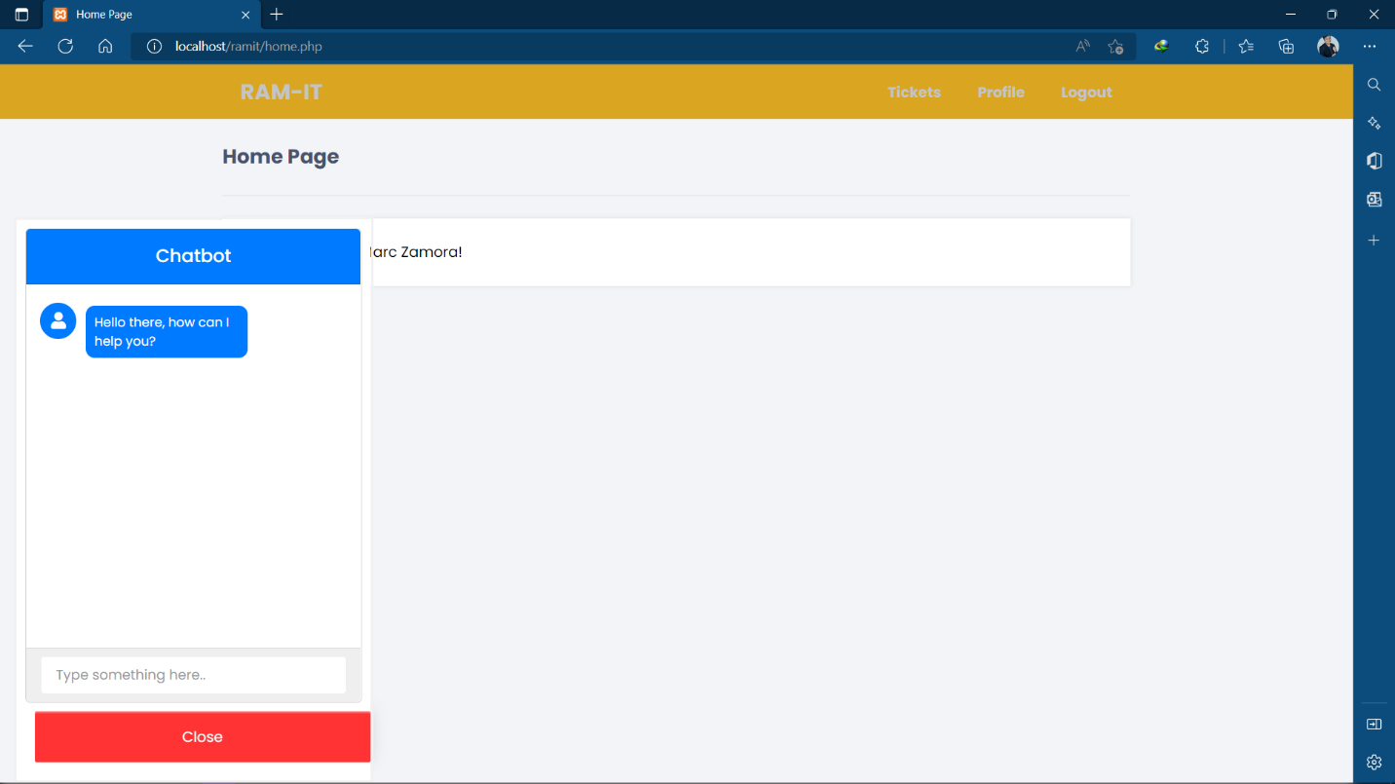

Figure : Chatbot (Student)

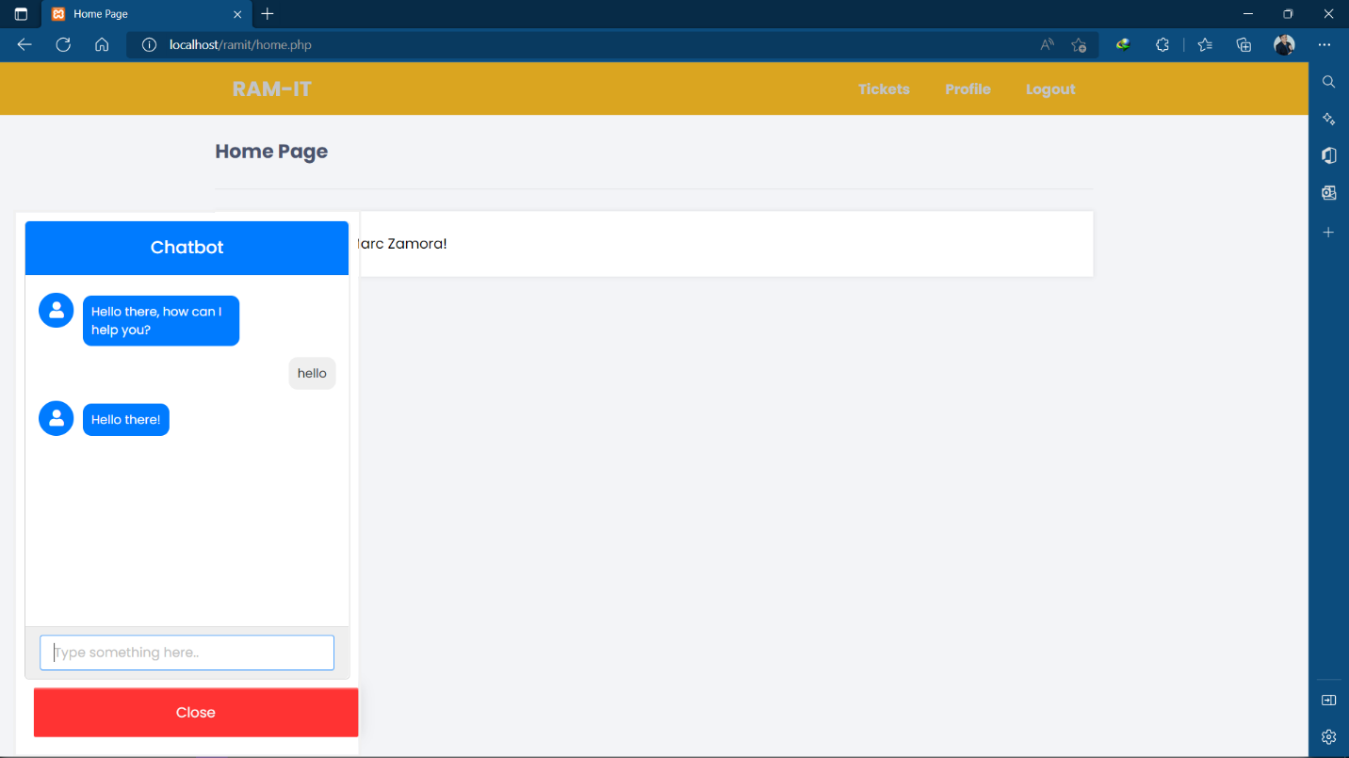

Figure : Chatbot Interaction (Student)

ITRO SUPERVISOR

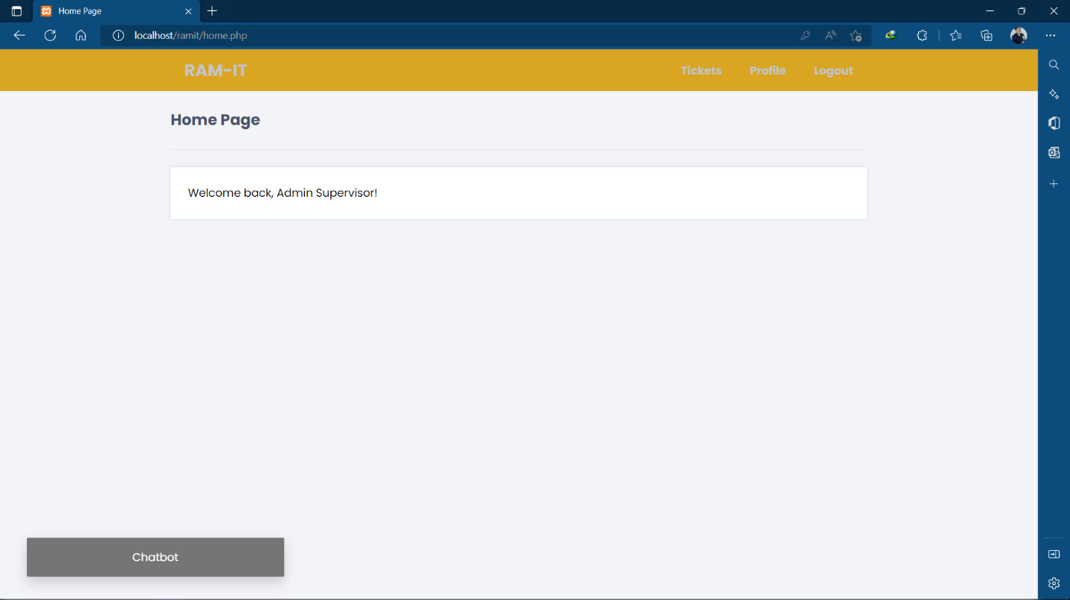

Figure : Home Page (Supervisor)

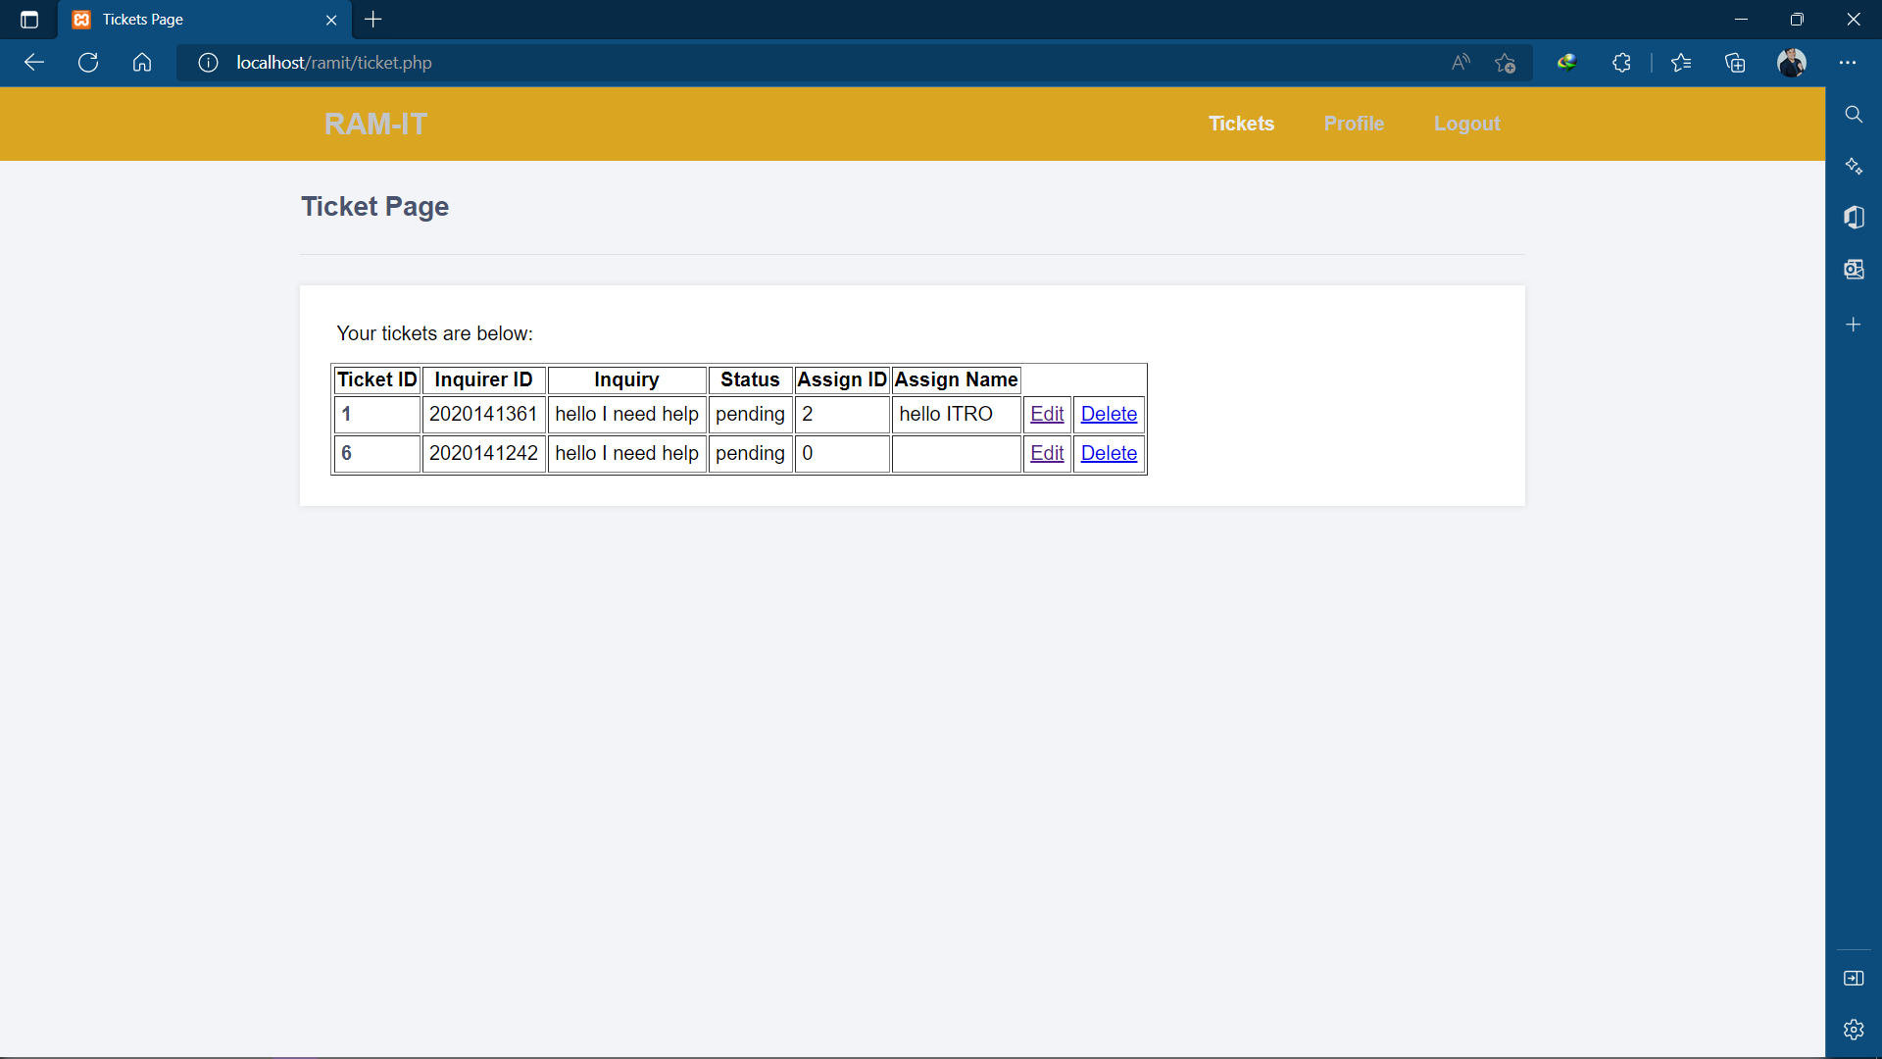

Figure : Tickets Page (Supervisor)

Figure : Assign Ticket to an ITRO employee (Supervisor)

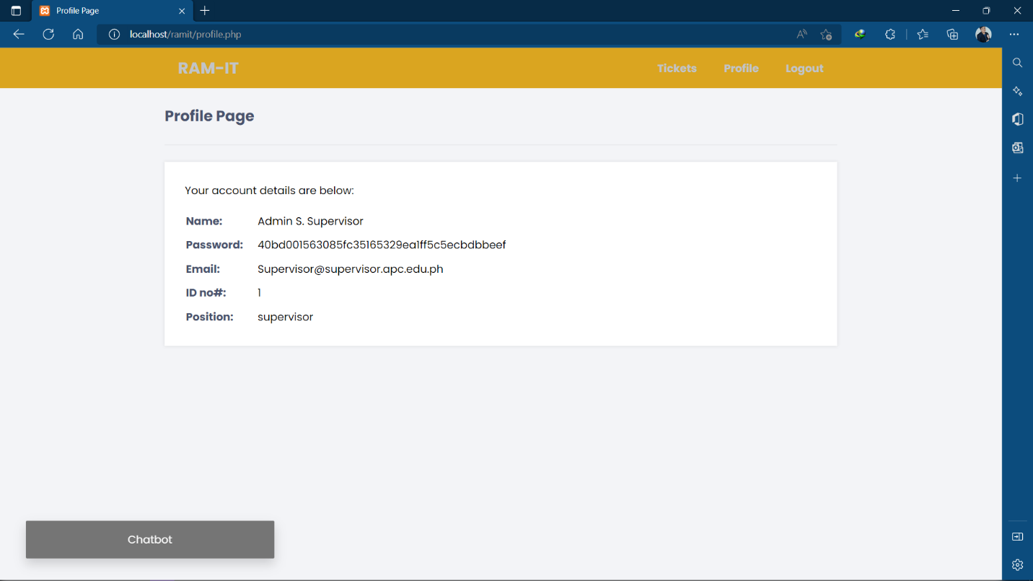

Figure : Profile (Supervisor)

ITRO IT SPECIALIST

Figure : Home Page (ITRO)

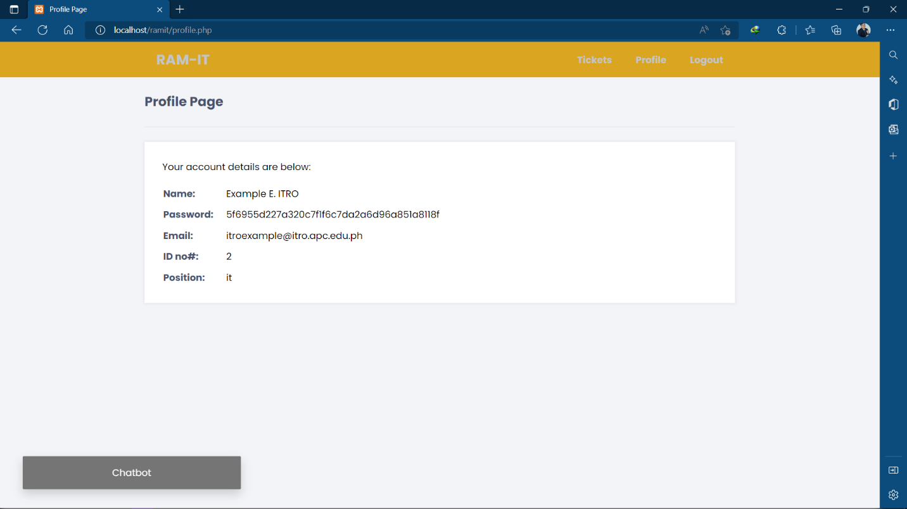

Figure : Profile (ITRO)

Figure : Ticket Page (ITRO)

Figure : Ticket# details (ITRO)

## 5.4 Use Classes and Characteristics

|  |  |
| --- | --- |
| *Roles* | *Description* |
| *APC Community* | *The user, APC Community is the one who inquires using the RAM-IT Website. If they are not satisfied with the answer of the ChatBot, they may proceed to submit a ticket. The ticket then becomes pending. The ITRO then addresses the ticket.* |
| *ITRO* | *The user, ITRO is the one who receives the tickets and addresses the ticket. They are the ones who provide customer support to the APC Community.* |

Table : Use Classes and Characteristics

# Conclusion

What the proponents finished is the research on the feasibility and viability of having a ticketing system implemented to benefit the ITRO. The proposed deliverables of the proposed project are accomplished during the duration of the monthly sprint. The decision of proponents, the client, the project adviser, and the consultant decided to reevaluate and revise the proposal and the main features of the previous project. The proposed ticketing system has the same intent and similar goal of implementing an IT solution to help aid the current systems of ITRO regarding the APC community's inquiries. The proponents' goal is to create a working ticketing system with additional supporting features indicated on the proposal during the development.

# References

|  |  |
| --- | --- |
| [1] | Digital Class World , "Importance of information technology in today’s world," Digital Class World , [Online]. Available: https://www.digitalclassworld.com/blog/importance-of-information-technology/#:~:text=Information%20technology%20helps%20to%20build,%2C%20storage%2C%20and%20efficient%20communication. [Accessed September 2022]. |
| [2] | T. G. D. a. J. F. e. C. M. C. Ferreira, "An In-Depth Study of Mobile Ticketing Services in Urban Passenger Transport: State of the Art and Future Perspectives," IGI Global , 2020. [Online]. Available: https://www.igi-global.com/chapter/an-in-depth-study-of-mobile-ticketing-services-in-urban-passenger-transport/249113. [Accessed September 2022]. |
| [3] | Freshworks Inc., "Freshworks: About us," Freshworks Inc., [Online]. Available: https://www.freshworks.com/company/about/?source=freshdesk&medium=referral&campaign=fdesk_footer_main. [Accessed September 2022]. |
| [4] | Spiceworks, "What is Spiceworks Cloud Help Desk?," Spiceworks, [Online]. Available: https://www.spiceworks.com/free-cloud-help-desk-software/. [Accessed September 2022]. |
| [5] | J. R. L. S. V. Omana, "Student Helpdesk System," IJESC, March 2017. [Online]. Available: https://ijesc.org/upload/59d8ff563e7788efb55a2dc75d70d862.Student%20Helpdesk%20System.pdf. [Accessed September 2022]. |
| [6] | Santa Ana College, "The Student Help Desk," Santa Ana College, [Online]. Available: https://www.sac.edu/StudentServices/digital-dons/Pages/The-Student-Help-Desk.aspx. [Accessed September 2022]. |
| [7] | Office of Educational Technology, "Students as Tech Support," Office of Educational Technology, [Online]. Available: https://tech.ed.gov/stories/students-as-tech-support/. [Accessed September 2022]. |
| [8] | D. S. M. G. R. C. Patricia O. Calora, "Exploring the Potential of a Ticketing-Based Student Support System for Open and Distance," December 2020. [Online]. Available: https://ijodel.com/wp-content/uploads/2021/08/004_Calora_et_al.pdf. [Accessed 2022 September]. |
| [9] | J. Giblett, "How chatbots are used in schools," Digistorm, 5 October 2021. [Online]. Available: https://insights.digistorm.com/en-au/chatbots-in-schools?hsLang=en-au. [Accessed September 2022]. |
| [10] | L. Pappano, "College Chatbots, With Names Like Iggy and Pounce, Are Here to Help," The New York Times, 8 May 2020. [Online]. Available: https://www.nytimes.com/2020/04/08/education/college-ai-chatbots-students.html. [Accessed September 2022]. |
| [11] | P. J. A. C. B. A. M. E. F. C.-L. L. P. P. a. M. C. A. Joane V. Serrano, "Ask Iska and IskOU:Analysis of UPOU's Chatbot for Information Support Services," June 2021. [Online]. Available: https://www.google.com/url?sa=t&rct=j&q=&esrc=s&source=web&cd=&ved=2ahUKEwiTjpOxgr76AhXYe94KHcNlAvIQFnoECBAQAQ&url=https%3A%2F%2Fijodel.com%2Fwp-content%2Fuploads%2F2021%2F09%2F005_Serrano_et_al.pdf&usg=AOvVaw3eL21x2CUgFPjnVNjbQsw2. [Accessed September 2022]. |
| [12] | J. Laukkonen, "What Is a Notification System?," Easytechjunkie, 20 September 2022. [Online]. Available: https://www.easytechjunkie.com/what-is-a-notification-system.htm. [Accessed September 2022]. |
| [13] | AIRSHIP, "Web Push Notifications Explained," AIRSHIP, [Online]. Available: https://www.airship.com/resources/explainer/web-push-notifications-explained/#:~:text=Web%20push%20notifications%20are%20notifications,desktop%20web%20and%20mobile%20web.. [Accessed September 2022]. |
| [14] | C. Lowe, "Web Push Notifications Mastery Guide," Insider, 2 December 2019. [Online]. Available: https://useinsider.com/what-is-web-push-notification/. [Accessed September 2022]. |
| [15] | SendPulse, "What is an SMS Notification? - Guide," SendPulse, 2 September 2022. [Online]. Available: https://sendpulse.com/support/glossary/sms-notification. [Accessed September 2022]. |
| [16] | SPARKPOST, "What product teams need to know about email notifications," SPARKPOST, [Online]. Available: https://www.sparkpost.com/academy/user-engagement/getting-started-email-notifications/. [Accessed September 2022]. |
| [17] | S. Peek and S. Angeles, "What Is Agile Scrum Methodology?," Business News Daily, 22 December 2021. [Online]. Available: https://www.businessnewsdaily.com/4987-what-is-agile-scrum-methodology.html. [Accessed 4 June 2022]. |

# Appendices

## Appendix A: Project Vision

**For** The APC Community

**Who** needs to have a better way to seek customer support from ITRO

**The** RAM-IT **is** ITRO’s ChatBot & Ticketing System Website

**That** requires the users to log in using the APC’s Microsoft account in order to access the following features: ChatBot & Ticketing System.

**Unlike** ITRO’s Email

**Out Product** has tendencies to accumulate multiple inquiries due to its direct communication.

## Appendix B: Roles & Responsibilities

|  |  |  |  |  |
| --- | --- | --- | --- | --- |
| **Aloya, Jayson** | **Langcauon, John Christopher** | **Prion, Jan Gabriel** | **Sajul, Marc Julian** | **Zamora, Marc** |
| *Scrum Master* | *Documentation / Product Developer* | *Product Developer* | *Product Owner* | *Main Programmer* |
| Statement of the Problem | Executive Summary | Project Context | Scope & Limitations | RRL |
| Objectives | Current Technical Background | Significance of the Project | Proposed Technical Background | Use Case Full Description |
| Event Table | User Stories | Conclusion | User Stories | List of Figures |
| Use Case Diagram | Video Editing | Comments Matrix | Gap Analysis | List of Tables |
| Context Diagram | Presentation Deck | Package Diagram | Entity-Relationship Diagram | References |
| Data Flow Diagrams | Deployment Diagram |  | Object Diagram | Team Meetings |
| Activity Diagrams |  |  | Class Diagram | Machine State Diagram |
| Use Classes and Characteristics |  |  | Release Plan |  |
| Project Vision |  |  | Mock-Up |  |
| Roles & Responsibilities |  |  | Product Roadmap |  |
| Presentation Deck |  |  | Comments Matrix |  |
| Comments Matrix |  |  | Sequence Diagram |  |
| Component Diagram |  |  |  |  |
| Package Diagram |  |  |  |  |

Table : Roles & Responsibilities

## Appendix C: Product Roadmap

|  |  |  |  |
| --- | --- | --- | --- |
| **June 2022**  **Milestone 1**   * Wireframe   June 22, 2022 | **September 2022**  **Milestone 2**   * Website blueprint * Website UI   **Milestone 3**   * Log In | **November 2022**  **Milestone 4**   * Ticketing System * Chat System * Notification System | **January 2023**  **Milestone 5**   * Open / Close Tickets * Ticket History * Generate Reports * Filter System |

|  |
| --- |
| **March 2023**  **Milestone 6**   * Chat Bot |

Figure : Product Roadmap

## Appendix D: Source Code

Figure : Source Code Github

<https://github.com/MarcZamora/RAM-IT>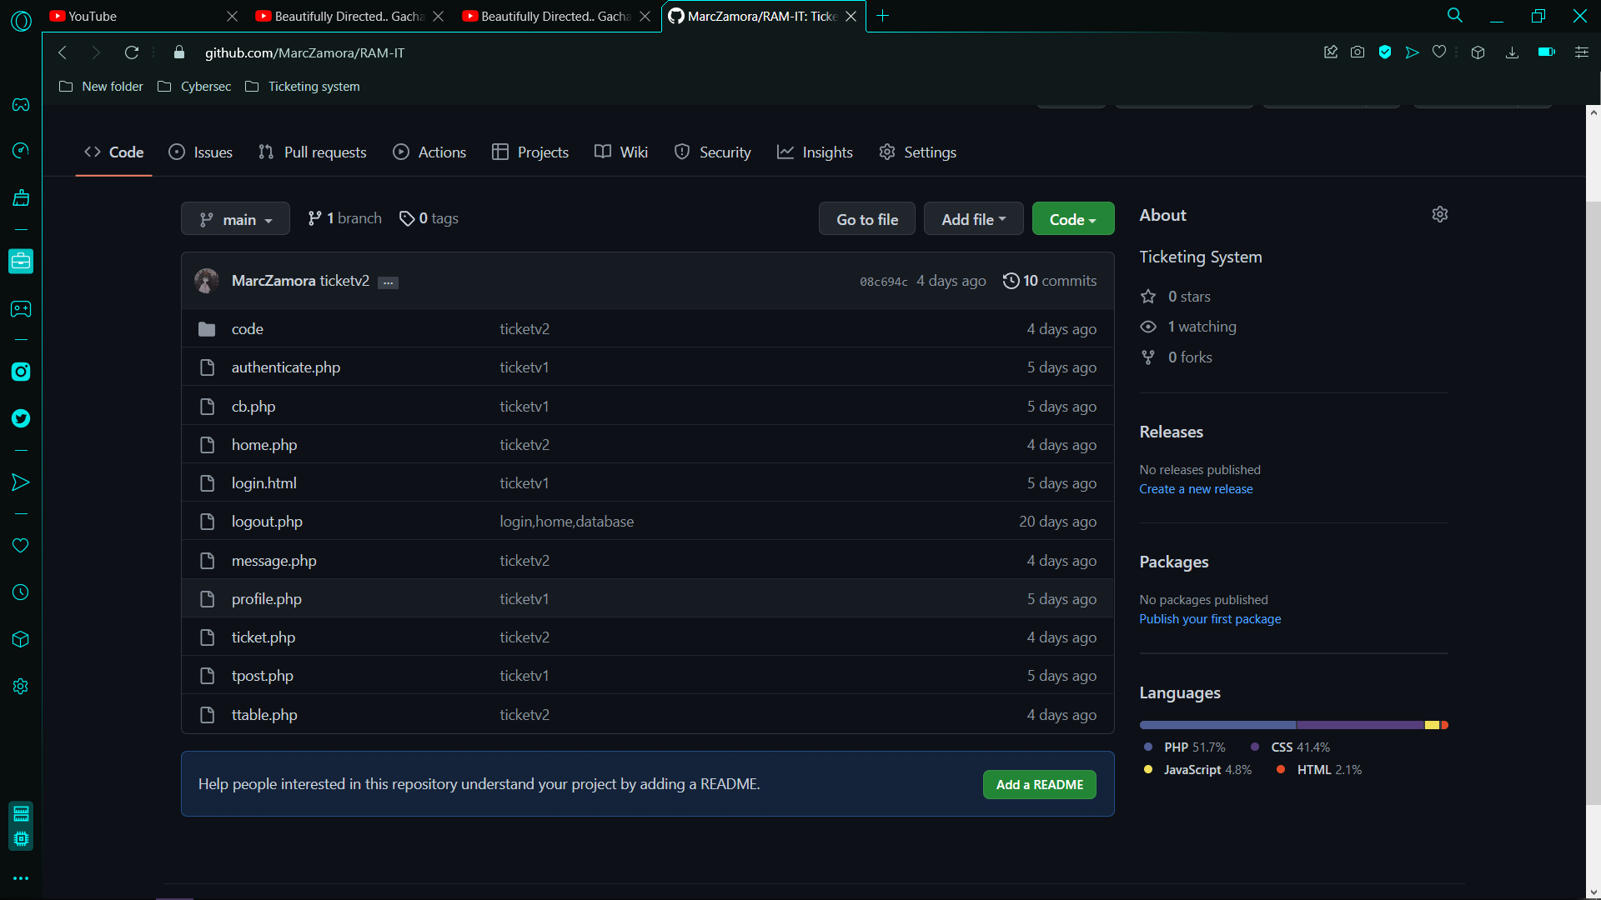

## Appendix E: Team Meetings

**Minutes of the Meeting - 8/28/22 Sunday**



Figure : Minutes of the Meeting - 8/28/22 Sunday

Opening:

Online meeting of the Optimum Five group called to order at 8:00 PM – 10:23 PM on August 28, 2022, in Microsoft Teams.

Present

Marc Zamora

Jayson Aloya

John Christopher Langcauon

Marc Julian Sajul

Jan Gabriel Prion

Absent

None

Model-View and Controller infographic

All of the documents and PowerPoints that are presented are made by Jayson Aloya

Agenda:

* MVC alterations
* Discussion and changes
* Previous Comment Matrix
* Discussion
* Progress Report – Week 2

Adjournment:

Meeting was adjourned in 10:23 PM by Jayson Aloya, as well as the next meeting will be held on August 28, 2022 (8:00 PM) online with the use of Microsoft Teams.

**Minutes of the Meeting - 8/29/22 Monday**



Figure : Minutes of the Meeting - 8/29/22 Monday

Opening:

Online meeting of the Optimum Five group called to order at 8:00 PM – 10:40 PM on August 29, 2022, in Microsoft Teams.

Present

Marc Zamora

Jayson Aloya

John Christopher Langcauon

Marc Julian Sajul

Jan Gabriel Prion

Absent

 None

MCV alteration and updates to the diagrams

All of the documents and PowerPoints that are presented are made by Jayson Aloya

Agenda:

* MCV alteration
* Discussion about changes
* MVC alterations
* Discussion and changes
* Even Table
* Discussion

Adjournment:

Meeting was adjourned in 10:40 PM by Jayson Aloya, as well as the next meeting will be held on August 29, 2022 (8:00 PM) online with the use of Microsoft Teams.

**Minutes of the Meeting - 8/31/22 Wednesday**



Figure : Minutes of the Meeting - 8/31/22 Wednesday

Opening:

Online meeting of the Optimum Five group called to order at 9:00 PM – 10:12 PM on August 31, 2022, in Microsoft Teams.

Present

Marc Zamora

Jayson Aloya

John Christopher Langcauon

Marc Julian Sajul

Jan Gabriel Prion

Absent

None

MCV alteration and updates to the diagrams

All of the documents and PowerPoints that are presented are made by Jayson Aloya

Agenda:

* MVC alterations
* Discussion and changes
* Even Table
* Discussion and changes

Adjournment:

Meeting was adjourned in 10:12 AM by Jayson Aloya, as well as the next meeting will be held on August 31, 2022 (9:00PM) online with the use of Microsoft Teams.

**Minutes of the Meeting - 9/7/22 Wednesday**

Figure : Minutes of the Meeting - 9/7/22 Wednesday

Opening:

Online meeting of the Optimum Five group called to order at 9:00 PM – 9:51 PM on September 7, 2022, in Microsoft Teams.

Present

Marc Zamora

Jayson Aloya

John Christopher Langcauon

Marc Julian Sajul

Absent

Jan Gabriel Prion

Diagrams and paper prep presentation

All of the documents and PowerPoints that are presented are made by Jayson Aloya

Agenda:

* Activity Diagram
* Discussion
* Object Diagram
* Discussion
* Sprint 2
* Midterm paper
* Comment Matrix

Adjournment:

Meeting was adjourned in 9:51 AM by Jayson Aloya, as well as the next meeting will be held on September 7, 2022 (9:00 PM) online with the use of Microsoft Teams.

**Minutes of the Meeting - 9/15/22 Wednesday**

Figure : Minutes of the Meeting - 9/15/22 Wednesday

Opening:

Online meeting of the Optimum Five group called to order at 9:30 AM – 11:42 AM on September 15, 2022, in Microsoft Teams.

Present

Marc Zamora

Jayson Aloya

John Christopher Langcauon

Marc Julian Sajul

Jan Gabriel Prion

Absent

None

RAM-IT

All of the documents and PowerPoints that are presented are made by Jayson Aloya

Agenda:

* Inform the client
* Updates
* Discussion about changes

Adjournment:

Meeting was adjourned in 11:42 AM by Jayson Aloya, as well as the next meeting will be held on September 15, 2022 (9:30 AM) online with the use of Microsoft Teams.

**Minutes of the Meeting - 9/20/22 Tuesday**

Figure : Minutes of the Meeting - 9/20/22 Tuesday

Opening:

Online meeting of the Optimum Five group called to order at 11:30 AM – 12:17 AM on September 20, 2022, in Microsoft Teams.

Present

Jayson Aloya

John Christopher Langcauon

Marc Julian Sajul

Jan Gabriel Prion

Absent

Marc Zamora

RAM-IT

All of the documents and PowerPoints that are presented are made by Jayson Aloya

Agenda:

* Present paper
* Updates
* Discussion about changes

• seek consultation to the consultant

Adjournment:

Meeting was adjourned in 12:17 AM by Jayson Aloya, as well as the next meeting will be held on September 20, 2022 (11:30 AM) online with the use of Microsoft Teams.

**Minutes of the Meeting - 9/21/22 Thursday**

Figure : Minutes of the Meeting - 9/21/22 Thursday

Opening:

Online meeting of the Optimum Five group called to order at 9:30 AM – 11:42 AM on September 21, 2022, in Microsoft Teams.

Present

Marc Zamora

Jayson Aloya

John Christopher Langcauon

Marc Julian Sajul

Absent

Jan Gabriel Prion

RAM-IT AI & Ticketing System

All of the documents and PowerPoints that are presented are made by Jayson Aloya

Agenda:

* Inform the client
* Updates
* Discussion about changes
* Question the statistics of inquiries in ITRO

Adjournment:

Meeting was adjourned in 11:42 AM by Jayson Aloya, as well as the next meeting will be held on September 21, 2022 (9:30 AM) online with the use of Microsoft Teams.

**Minutes of the Meeting - 9/23/22 Friday**

Figure : Minutes of the Meeting - 9/23/22 Friday

Opening:

Online meeting of the Optimum Five group called to order at 9:30 AM – 10:42 AM on September 23, 2022, in Microsoft Teams.

Present

Marc Zamora

Jayson Aloya

John Christopher Langcauon

Marc Julian Sajul

Jan Gabriel Prion

Absent

None

RAM-IT AI & Ticketing System

All of the documents and PowerPoints that are presented are made by Jayson Aloya

Agenda:

* Inform the client
* Updates
* Discussion about changes
* Question the statistics of inquiries in ITRO

Adjournment:

Meeting was adjourned in 10:42 AM by Jayson Aloya, as well as the next meeting will be held on September 23, 2022 (9:30 AM) online with the use of Microsoft Teams.

**Minutes of the Meeting - 9/25/22 Sunday**



Figure : Minutes of the Meeting - 9/25/22 Sunday

Opening:

Online meeting of the Optimum Five group called to order at 9:00 PM – 6:56 PM on September 25, 2022, in Microsoft Teams.

Present

Marc Zamora

Jayson Aloya

John Christopher Langcauon

Marc Julian Sajul

Jan Gabriel Prion

Absent

None

Change of Proposal

All of the documents and PowerPoints that are presented are made by Jayson Aloya

Agenda:

* Project Paper
* Discussion about changes
* Diagrams
* Discussion
* Schedule
* Discussion
* QNA

Adjournment:

Meeting was adjourned in 6:56 PM by Jayson Aloya, as well as the next meeting will be held on September 25, 2022 (9:00 PM) online with the use of Microsoft Teams.

**Minutes of the Meeting - 9/27/22 Tuesday**

Figure : Minutes of the Meeting - 9/27/22 Tuesday

Opening:

Online meeting of the Optimum Five group called to order at 9:30 AM – 10:42 AM on September 27, 2022, in Microsoft Teams.

Present

Marc Zamora

Jayson Aloya

John Christopher Langcauon

Marc Julian Sajul

Jan Gabriel Prion

Absent

None

RAM-IT AI & Ticketing System

All of the documents and PowerPoints that are presented are made by Jayson Aloya

Agenda:

* Inform the client
* Updates
* Discussion about changes

Adjournment:

Meeting was adjourned in 10:42 AM by Jayson Aloya, as well as the next meeting will be held on September 27, 2022 (9:30 AM) online with the use of Microsoft Teams.

**Minutes of the Meeting - 9/29/22 Thursday**

Figure : Minutes of the Meeting - 9/29/22 Thursday

Opening:

Online meeting of the Optimum Five group called to order at 9:30 AM – 10:42 AM on September 29, 2022, in Microsoft Teams.

Present

Marc Zamora

Jayson Aloya

John Christopher Langcauon

Marc Julian Sajul

Absent

Jan Gabriel Prion

RAM-IT AI & Ticketing System

All of the documents and PowerPoints that are presented are made by Jayson Aloya

Agenda:

* Inform the client
* Updates
* Discussion about changes
* Question the statistics of inquiries in ITRO

Adjournment:

Meeting was adjourned in 10:42 AM by Jayson Aloya, as well as the next meeting will be held on September 29, 2022 (9:30 AM) online with the use of Microsoft Teams.

**Minutes of the Meeting - 9/30/22 Friday**



Figure : Minutes of the Meeting - 9/30/22 Friday

Opening:

Online meeting of the Optimum Five group called to order at 10:00 PM – 3:04 AM on September 30, 2022, in Microsoft Teams.

Present

Marc Zamora

Jayson Aloya

John Christopher Langcauon

Marc Julian Sajul

Absent

Jan Gabriel Prion

RAM-IT AI & Ticketing System

All of the documents and PowerPoints that are presented are made by Jayson Aloya

Agenda:

* Updates
* Discussion about changes

Adjournment:

Meeting was adjourned in 3:03 AM by Jayson Aloya, as well as the next meeting will be held on September 30, 2022 (10:00 PM) online with the use of Microsoft Teams.

**Minutes of the Meeting - 10/1/22 Saturday**

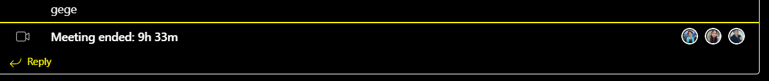

Figure : Minutes of the Meeting - 10/1/22 Saturday

Opening:

Online meeting of the Optimum Five group called to order at 10:00 AM – 6:00 PM on October 1, 2022, in Microsoft Teams.

Present

Marc Zamora

Jayson Aloya

John Christopher Langcauon

Marc Julian Sajul

Absent

Jan Gabriel Prion

RAM-IT AI & Ticketing System

All of the documents and PowerPoints that are presented are made by Jayson Aloya

Agenda:

* Updates
* Discussion about changes

Adjournment:

Meeting was adjourned in 6:33 PM by Jayson Aloya, as well as the next meeting will be held on October 1, 2022 (10:00 AM) online with the use of Microsoft Teams.

**Minutes of the Meeting - 10/1/22 Saturday**

Figure : Minutes of the Meeting - 10/1/22 Saturday

Opening:

Online meeting of the Optimum Five group called to order at 11:00 PM – 3:34 PM on October 1, 2022, in Microsoft Teams.

Present

Marc Zamora

Jayson Aloya

John Christopher Langcauon

Marc Julian Sajul

Absent

Jan Gabriel Prion

RAM-IT AI & Ticketing System

All of the documents and PowerPoints that are presented are made by Jayson Aloya

Agenda:

* Updates
* Discussion about changes

Adjournment:

Meeting was adjourned in 3:34 AM by Jayson Aloya, as well as the next meeting will be held on October 1, 2022 (11:00 PM) online with the use of Microsoft Teams.

**Minutes of the Meeting - 10/20/22 Tuesday**

Figure : Minutes of the Meeting - 10/20/22 Tuesday

Opening:

Online meeting of the Optimum Five group called to order at 9:00 AM – 10:00 AM on October 15, 2022, in Microsoft Teams.

Present

Marc Zamora

Jayson Aloya

John Christopher Langcauon

Marc Julian Sajul

Jan Gabriel Prion

Absent

RAM-IT AI & Ticketing System

All of the documents and PowerPoints that are presented are made by Jayson Aloya

The prototype was presented by Marc E. Zamora

Agenda:

* Updates
* Discussion about the prototype

Adjournment:

Meeting was adjourned in 10 AM by Jayson Aloya, as well as the next meeting will be held on October 27, 2022 (11:00 PM) online with the use of Microsoft Teams.

**Minutes of the Meeting - 10/20/22 Thursday**

Figure : Minutes of the Meeting - 10/20/22 Thursday

Opening:

Online meeting of the Optimum Five group called to order at 9:30 AM – 9:53 AM on October 10, 2022, in Microsoft Teams.

Present

Marc Zamora

Jayson Aloya

John Christopher Langcauon

Marc Julian Sajul

Jan Gabriel Prion

Absent

RAM-IT AI & Ticketing System

All of the documents and PowerPoints that are presented are made by Jayson Aloya

The prototype was presented by Marc E. Zamora

Agenda:

* Updates
* Discussion about the prototype

Adjournment:

Meeting was adjourned in 10 AM by Jayson Aloya, as well as the next meeting will be held on October 27, 2022 (11:00 PM) online with the use of Microsoft Teams.

**Minutes of the Meeting - 11/4-6/22 Friday - Sunday**

Figure : Minutes of the Meeting - 11/4-6/22 Friday - Sunday

Opening:

Online meeting of the Optimum Five group called to order at 11:00 PM – 3:34 PM on November 4, 2022, in Microsoft Teams.

Present

Marc Zamora

Jayson Aloya

John Christopher Langcauon

Marc Julian Sajul

Jan Gabriel Prion

Absent

Jan Gabriel Prion (Friday)

Marc Julian Sajul (Friday)

RAM-IT AI & Ticketing System

All of the documents and PowerPoints that are presented are made by Jayson Aloya

Agenda:

* Updates
* Discussion about changes in the prototype and paper

Adjournment:

Meeting was adjourned in 6 PM by Jayson Aloya, as well as the next meeting will be held on November 7, 2022 (11:00 PM) online with the use of Microsoft Teams.